Sixth Annual SoCal Small Baby Consortium

November 18, 2025

Purpose
The SoCal Small Baby Consortium is a collaborative initiative aimed at improving care for small and premature infants. It focuses on standardizing practices, collecting data, educating healthcare professionals, and supporting research to enhance neonatal outcomes across the region.
Registration Fee: $50.00

Target Audience
Specialties – Pediatrics, Neonatal / Perinatal Medicine
Professions – Physician, Allied Health Professional, Medical Student, Nurse, Nurse Practitioner, Pharmacist, Physician Assistant, Resident Physician

Activity Objectives
1 Enhance clinical knowledge in the management of extremely low birth weight (ELBW) and very preterm neonates, with a focus on current best practices and evidence-based care.
2 Promote understanding of early stabilization techniques, including golden hour protocols, thermoregulation, respiratory support, and cardiovascular management
3 Update participants on nutritional strategies for small and preterm infants, including early parenteral nutrition, human milk feeding, and growth monitoring.
4 Foster awareness of neuroprotective approaches and long-term neurodevelopmental follow-up protocols in NICU graduates.
5 Encourage multidisciplinary collaboration among neonatologists, pediatricians, nurses, and allied health professionals for holistic small baby care.
6 Provide a platform for case-based discussions and panel interactions to address real-world challenges and controversies in neonatal intensive care.

Accreditation Statement
The University of California, Irvine School of Medicine is accredited by the Accreditation Council for Continuing Medical Education to provide continuing medical education for physicians.

Designation Statement
The University of California, Irvine School of Medicine designates this Live Activity for a maximum of 5.75 AMA PRA Category 1 Credit(s)™. Physicians should claim only the credit commensurate with the extent of their participation in the activity.

California Assembly Bill 1195 and 241
This activity is in compliance with California Assembly Bill 1195 and 241, which require CME activities with patient care components to include curriculum in the subjects of cultural and linguistic competency & implicit bias. It is the intent of AB 1195 and AB 241 to encourage physicians and surgeons, CME providers in the State of California, and the Accreditation Council for Continuing Medical Education to meet the cultural and linguistic concerns of a diverse patient population and reduce health disparities through appropriate professional development. Please see the CME website, https://www.meded.uci.edu/CME/ for AB 1195 and AB 241 resources.





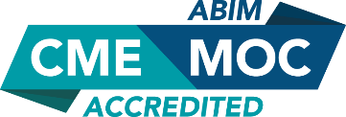

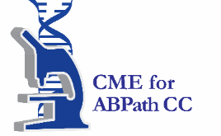

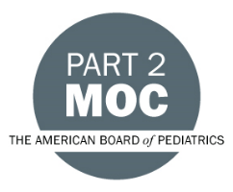

Faculty & Planner Disclosures
The University of California, Irvine School of Medicine adheres to ACCME Criteria, Standards and Policies regarding industry support of continuing medical education. Disclosure of faculty and their commercial relationships will be made prior to the activity.
University of California, Irvine School of Medicine Continuing Medical Education adheres to the ACCME’s Standards for Integrity and Independence in Accredited Continuing Education. Any individuals in a position to control the content of a CE activity, including faculty, planners, reviewers or others are required to disclose all relevant financial relationships with ineligible entities (commercial interests). All relevant conflicts of interest have been mitigated prior to the commencement of the activity.

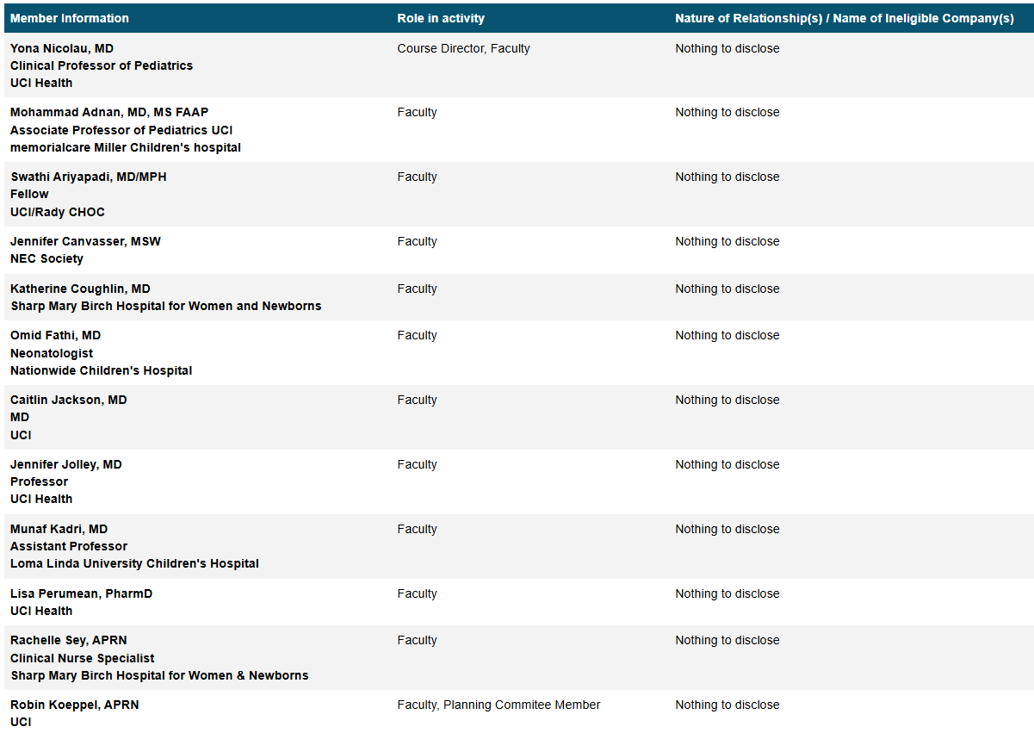

Agenda/Schedule
https://uci.cloud-cme.com/course/courseoverview?P=0&EID=4971

Acknowledgement of Commercial Support
We would like to thank the following companies for exhibiting at the event:
Abbott Nutrition
Bunnell Inc.
Masimo
Mead Johnson Nutrition
Sanofi
UCI Health

