38th Annual HIV/AIDS on the Front Line Conference

October 23, 2025

Purpose
The HIV/AIDS on the Front Line Conference is one of the oldest annual conferences in the nation focusing on HIV and has been a pillar of the HIV treating community in Southern California for 38 years. It is hosted by the University of California, Irvine, Division of Infectious Diseases in collaboration with the Orange County Health Care Agency. It is targeted towards regional healthcare providers treating and preventing HIV. The goal is to provide healthcare professionals with the opportunity to enhance their knowledge and treatment skills with new and updated data. The faculty will be comprised of national, regional, and local experts. Topics include practical clinical information for treatment as well as health related social issues which are pertinent to HIV-related care. The planning committee consists of the UCI faculty, Orange County Health Care Agency HIV leadership, and HIV Community Based Organizations. The committee membership represents different disciplines and diversity that reflect the attendees.

Target Audience
Specialties – Medicine, General Internal Medicine & Primary Care, Infectious Diseases
Professions – Physician, Non-Physician, Allied Health Professional, Dentist, Medical Assistant, Medical Student, Nurse, Nurse Practitioner, Other, Pharmacist, Pharmacy Technician, Physician Assistant, Registered Dietitian, Resident Physician, Clinical Social Worker, Psychologist

Activity Objectives
1 Describe new and current advances in antiviral treatment for the care and prevention of patients with HIV, or at risk for, HIV.
2 Recognize issues related to diagnosis, treatment, and prevention of sexually transmitted infections.
3 Recognize how social factors, mental health issues, and/or drug use can act as a barrier to successful outcomes in individuals living with, or at risk for, HIV.

Accreditation Statement
The University of California, Irvine School of Medicine is accredited by the Accreditation Council for Continuing Medical Education to provide continuing medical education for physicians.

Designation Statement
The University of California, Irvine School of Medicine designates this Live Activity for a maximum of 5.25 AMA PRA Category 1 Credit(s)™. Physicians should claim only the credit commensurate with the extent of their participation in the activity.

California Assembly Bill 1195 and 241
This activity is in compliance with California Assembly Bill 1195 and 241, which require CME activities with patient care components to include curriculum in the subjects of cultural and linguistic competency & implicit bias. It is the intent of AB 1195 and AB 241 to encourage physicians and surgeons, CME providers in the State of California, and the Accreditation Council for Continuing Medical Education to meet the cultural and linguistic concerns of a diverse patient population and reduce health disparities through appropriate professional development. Please see the CME website, https://www.meded.uci.edu/CME/ for AB 1195 and AB 241 resources.







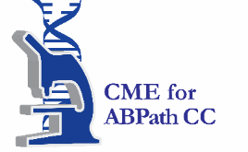

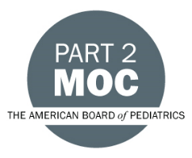

Faculty & Planner Disclosures
The University of California, Irvine School of Medicine adheres to ACCME Criteria, Standards and Policies regarding industry support of continuing medical education. Disclosure of faculty and their commercial relationships will be made prior to the activity.

University of California, Irvine School of Medicine Continuing Medical Education adheres to the ACCME’s Standards for Integrity and Independence in Accredited Continuing Education. Any individuals in a position to control the content of a CE activity, including faculty, planners, reviewers, or others are required to disclose all relevant financial relationships with ineligible entities (commercial interests). All relevant conflicts of interest have been mitigated prior to the commencement of the activity.
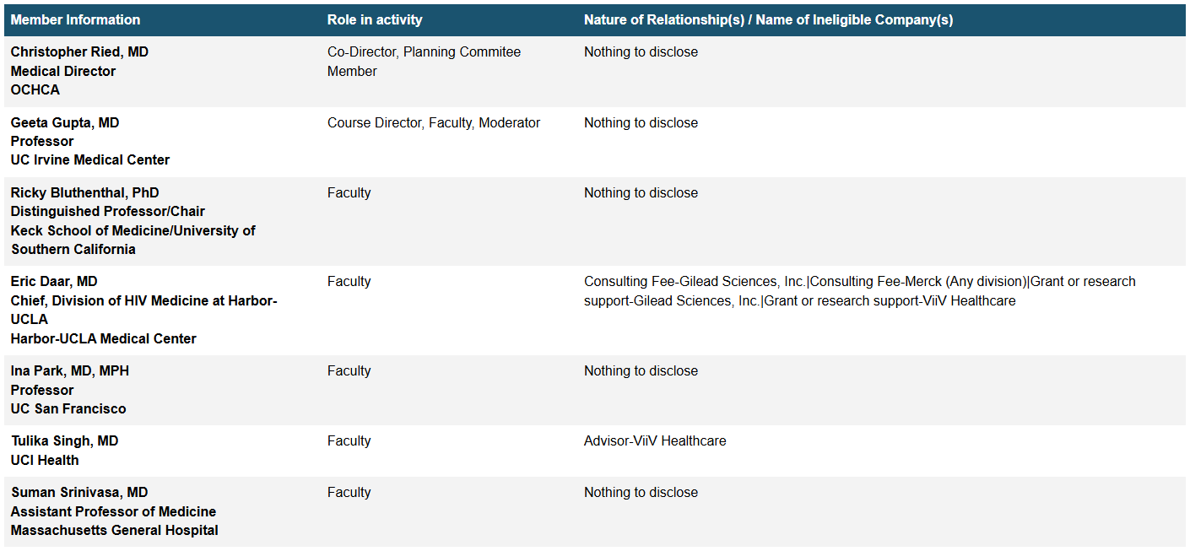
Agenda
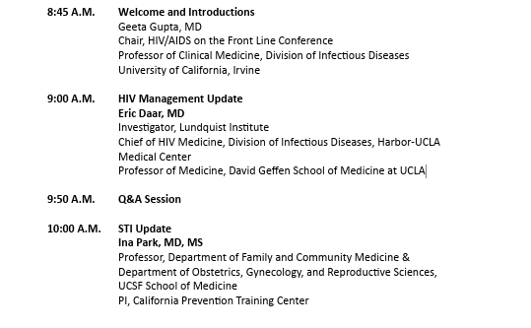
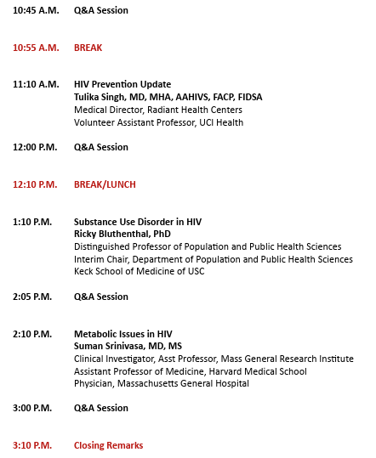

Acknowledgement of Commercial Support
We wish to thank the following organizations for their support at this conference:
Gilead Sciences - financial support
ViiV Healthcare - financial support

We wish to thank the following organizations for exhibiting at this conference:
Gilead Sciences - Prevention
Gilead Sciences - Treatment
Merck & Co.
Shionogi
ViiV Healthcare - Prevention
ViiV Healthcare - Treatment

