Pacific Coast Pediatric Ophthalmology and Strabismus Symposium

April 11, 2026

Purpose
This one-day event will bring together colleagues and experts from across the West Coast to share insights and advancements in amblyopia & strabismus, global pediatric eye care, and innovative surgical techniques. It will be a special opportunity to connect with peers, exchange clinical pearls, and strengthen our collective expertise — while also inspiring the next generation of pediatric ophthalmologists!

Target Audience
Specialties – Ophthalmology
Professions – Physician, Other, Resident Physician

Activity Objectives
1 Evaluate and manage pediatric anterior segment abnormalities and pediatric glaucoma, incorporating current diagnostic techniques and treatment strategies to optimize visual outcomes.
2 Describe the genetic basis of pediatric ocular diseases, recognize systemic conditions associated with pediatric eye disorders, and apply genetic testing to guide diagnosis and management.
3 Understand retinal findings associated with abusive head trauma, inherited retinal disorders, retinoblastoma, and retinopathy of prematurity.
4 Understand the genetic basis of pediatric ocular diseases and recognize systemic conditions associated with pediatric eye disorders.
5 Diagnose and manage torsional and oblique strabismus, understanding appropriate surgical interventions to improve ocular alignment and visual function.
6 Apply new techniques for horizontal strabismus surgical dosing in special situations, dose adjustment in classic strabismus, and botox augmentation on large esotropia.
7 Better understand complex strabismus cases in both adults and children, evaluate the effects of bupivacaine on extraocular muscles, and utilize advanced methods to manage cranial nerve palsies.

Accreditation Statement
The University of California, Irvine School of Medicine is accredited by the Accreditation Council for Continuing Medical Education to provide continuing medical education for physicians.

Designation Statement
The University of California, Irvine School of Medicine designates this Live Activity for a maximum of 8.00 AMA PRA Category 1 Credit(s)™. Physicians should claim only the credit commensurate with the extent of their participation in the activity.

California Assembly Bill 1195 and 241
This activity is in compliance with California Assembly Bill 1195 and 241, which require CME activities with patient care components to include curriculum in the subjects of cultural and linguistic competency & implicit bias. It is the intent of AB 1195 and AB 241 to encourage physicians and surgeons, CME providers in the State of California, and the Accreditation Council for Continuing Medical Education to meet the cultural and linguistic concerns of a diverse patient population and reduce health disparities through appropriate professional development. Please see the CME website, https://www.meded.uci.edu/CME/ for AB 1195 and AB 241 resources.





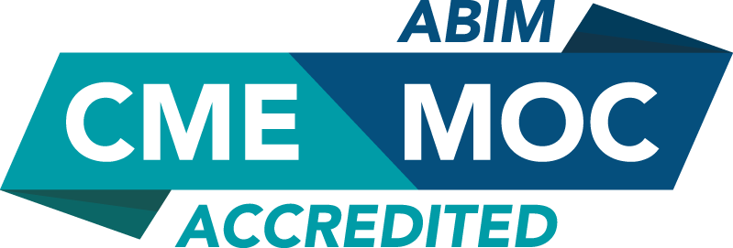

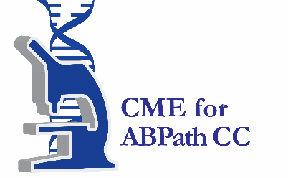

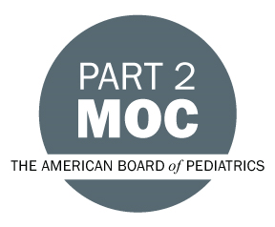

Faculty & Planner Disclosures
University of California, Irvine School of Medicine Continuing Medical Education adheres to the ACCME’s Standards for Integrity and Independence in Accredited Continuing Education. Any individuals in a position to control the content of a CE activity, including faculty, planners, reviewers, or others are required to disclose all relevant financial relationships with ineligible entities (commercial interests). All relevant conflicts of interest have been mitigated prior to the commencement of the activity.

Name of individual | Individual's role in activity | Nature of Relationship(s) / Name of Ineligible Company(s)
Tessnim Ahmad, MD | Faculty | Nothing to disclose - 01/24/2026
Amal Al-Lozi, MD | Faculty | Nothing to disclose - 01/29/2026
Rahul Bhola, MD | Faculty | Consulting Fee-Sydnexis - 01/21/2026
John E Bishop, MD | Faculty | Nothing to disclose - 02/04/2026
Shyamanga Borooah, MD | Faculty | Grant or research support-Janssen (Any division)|Grant or research support-ocugen|Paid consultant-AAVantgarde|Grant or research support-JCYTE|Grant or research support-Belite bio - 02/13/2026
Joe L Demer, MD | Faculty | Nothing to disclose - 01/30/2026
Craig Donaldson, MBBS | Faculty
Sonal Farzavandi, MBBS | Faculty | Nothing to disclose - 02/20/2026
Mona Fayad, MD | Faculty
Douglas Fredrick, MD | Faculty | Nothing to disclose - 01/07/2026
Charlotte Gore, MD | Co-Director | Nothing to disclose - 04/30/2025
David Granet, MD | Faculty
Lauren Hennein, MD | Faculty | Nothing to disclose - 02/03/2026
Monica Khitri, MD | Faculty | Nothing to disclose - 01/16/2026
Gaby Lahaie Luna, MD | Faculty
Scott Lambert, MD | Faculty | Nothing to disclose - 01/21/2026
Mansoor Movaghar, MD | Faculty | Nothing to disclose - 02/10/2026
Faruk Orge, MD | Faculty
Bibiana Reiser, MD | Faculty
Leah Reznick, MD | Faculty | Nothing to disclose - 01/21/2026
Mohammad Riazi, MD | Faculty | Nothing to disclose - 01/21/2026
Shira Robbins, MD, FAAO, FAAP | Faculty | Nothing to disclose - 01/25/2026
Sarah Rodriguez, MD | Faculty | Nothing to disclose - 02/25/2026
Jolene Rudell, MD, PhD | Faculty | Nothing to disclose - 01/21/2026
Nathan Scott, MD | Faculty | Nothing to disclose - 02/10/2026
Ann Shue, MD, Clinical Assistant Professor | Faculty | Nothing to disclose - 01/22/2026
Deion Sims, MD | Faculty | Nothing to disclose - 02/04/2026
Yi Ning J Strube, MD, MS FRCSC DABO | Faculty | Nothing to disclose - 01/16/2026
Donny Suh, MD, MBA | Course Director, Faculty | Nothing to disclose - 05/02/2025
Soh Youn Suh, MD | Faculty | Nothing to disclose - 01/12/2026
Federico G Velez, MD | Faculty | Nothing to disclose - 02/25/2026
Lorri B Wilson, MD | Faculty | Nothing to disclose - 02/10/2026
Kenneth Wright, MD | Faculty

Agenda
[INSERT AGENDA HERE MANUALLY]

Acknowledgement of Exhibitors
We wish to thank the following organizations for exhibiting at this educational activity:
Norlase
Recordati

