UC Irvine International Women's Health and Pelvic Reconstruction Course

August 22, 2026

Purpose
This one-day virtual course offers specialized training in women's health and pelvic reconstruction. Experts will provide updates on the management of Overactive Bladder, Stress Urinary Incontinence, Female Sexual Dysfunction, Hormonal health, and Pelvic Organ Prolapse. Join us for advanced lessons and participate in live Q&A discussions with expert faculty to bridge the gap between emerging research and daily clinical practice.

Target Audience
Specialties – Urology
Professions – Physician, Non-Physician, Allied Health Professional, Medical Student, Nurse, Nurse Practitioner, Physical Therapist, Physician Assistant, Resident Physician

Activity Objectives
1 Describe current neuromodulation techniques for overactive bladder, including sacral neuromodulation and tibial nerve stimulation.
2 Evaluate patient selection criteria for botulinum toxin versus neuromodulation for OAB.
3 Compare surgical approaches to stress urinary incontinence, including bulking agents, TVT, TOT, and mini-sling.
4 Formulate a management strategy for persistent SUI after prior sling surgery.
5 Identify and manage female sexual pain disorders including vestibulodynia, pudendal neuralgia, PGAD, and clitorodynia.
6 Identify high-yield vulvar dermatopathologic diagnoses.
7 Discuss hormonal management options for perimenopause and menopause, including systemic and local therapies.
8 Compare hormonal and non-hormonal options for female libido concerns.
9 Describe advanced robotic techniques for pelvic organ prolapse repair, including revision sacralcolpopexy.
10 Compare current sacrospinous fixation devices and techniques.

Accreditation Statement
The University of California, Irvine School of Medicine is accredited by the Accreditation Council for Continuing Medical Education to provide continuing medical education for physicians.

Designation Statement
The University of California, Irvine School of Medicine designates this Live Activity for a maximum of 5.75 AMA PRA Category 1 Credit(s)™. Physicians should claim only the credit commensurate with the extent of their participation in the activity.

California Assembly Bill 1195 and 241
This activity is in compliance with California Assembly Bill 1195 and 241, which require CME activities with patient care components to include curriculum in the subjects of cultural and linguistic competency & implicit bias. It is the intent of AB 1195 and AB 241 to encourage physicians and surgeons, CME providers in the State of California, and the Accreditation Council for Continuing Medical Education to meet the cultural and linguistic concerns of a diverse patient population and reduce health disparities through appropriate professional development. Please see the CME website, https://www.meded.uci.edu/CME/ for AB 1195 and AB 241 resources.





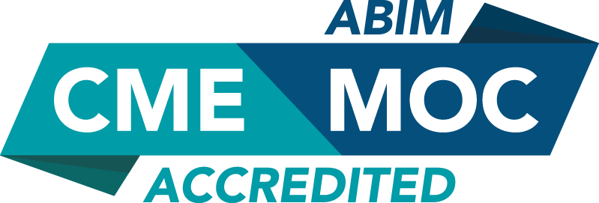



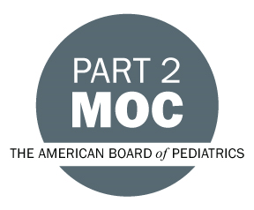



Faculty & Planner Disclosures
University of California, Irvine School of Medicine Continuing Medical Education adheres to the ACCME’s Standards for Integrity and Independence in Accredited Continuing Education. Any individuals in a position to control the content of a CE activity, including faculty, planners, reviewers, or others are required to disclose all relevant financial relationships with ineligible entities (commercial interests). All relevant conflicts of interest have been mitigated prior to the commencement of the activity.

Name of individual | Individual's role in activity | Nature of Relationship(s) / Name of Ineligible Company(s)
Corey R Babb, DO, FACOOG, IF, MSCP | Faculty | Speakers Bureau-Astellas (Any division)|Consulting Fee-Organicare - 06/04/2026
Taylor Brueseke, MD | Faculty | Nothing to disclose - 07/01/2026
Olivia Chang, MD, MPH | Course Director, Faculty | Nothing to disclose - 03/30/2026
Alexis Chesrow, MD | Faculty | Nothing to disclose - 08/04/2026
Sarah Cipriani, MD | Faculty | Nothing to disclose - 06/19/2026
Carly Crowder, MD | Faculty | Nothing to disclose - 07/08/2026
Ty Erickson, MD | Faculty | Paid consultant-Coloplast, Uromeme, Soranus, ARMS, - 06/19/2026
suzanne gilberg, MD, FACOG | Faculty | Nothing to disclose - 07/06/2026
Howard Goldman, MD | Faculty | Consulting Fee-Medtronic (Any division)|Consulting Fee-Sumitomo Pharma|Consulting Fee-AbbVie (Any division)|Consulting Fee-minze|Consulting Fee-laborie|Consulting Fee-Boston Scientific Corporation - 06/04/2026
Irwin Goldstein, MD | Faculty | Advisor-Endo Pharmaceuticals, Inc.|Speakers Bureau-Verity - 09/04/2025
Ly Hoang Roberts, MD | Faculty | Nothing to disclose - 07/13/2026
Lawrence Jenkins, MD, MBA, FACS | Faculty | Nothing to disclose - 07/08/2026
Jill Krapf, MD | Faculty | Stocks or stock options, excluding diversified mutual funds-Evvy|Advisor-AbbVie (Any division)|Independent Contractor (included contracted research)-Leo Pharmaceuticals |Advisor-Pelva Health|Honoraria-UpToDate - 07/07/2026
Catherine Matthews, MD, FACS, FACOG | Faculty | Consulting Fee-Boston Scientific Corporation|Consulting Fee-Coloplast|Honoraria-Neomedic|Consulting Fee-Johnson & Johnson|Grant or research support-Coloplast|Grant or research support-Boston Scientific Corporation - 06/08/2026
Andrea Murina, MD | Faculty | Speakers Bureau-AbbVie (Any division)|Speakers Bureau-Amgen, Inc.|Speakers Bureau-Galderma (Any division)|Advisor-Leo Pharma|Speakers Bureau-Pfizer (Any division)|Speakers Bureau-Johnson & Johnson|Speakers Bureau-Ortho Dermatologics|Speakers Bureau-UCB|Speakers Bureau-Novartis Corporation Pharmaceuticals - 06/10/2026
Sasha Orpilla-Advani, MBA | Activity Coordinator | Nothing to disclose - 03/06/2026
Lucila Pavan, MD | Faculty | Nothing to disclose - 05/28/2026
Rachel Pope, MD, MPH | Faculty | Consulting Fee-Astellas (Any division)|Consulting Fee-Johnson & Johnson|Consulting Fee-Bayer - 07/20/2026
Caroline Pukall, PhD, C.Psych | Faculty | Nothing to disclose - 06/05/2026
Sameena Rahman, MD, FACOG, MSCP, IF, Clinical Assistant Professor of OBGYN Northwestern Feinberg School of Medicine | Faculty | Speakers Bureau-Dare Pharmaceuticals - 07/27/2026
Zhina Sadeghi, MD | Faculty | Nothing to disclose - 06/04/2026
MAURIZIO SERATI, MD | Faculty | Nothing to disclose - 06/04/2026
Suzette E Sutherland, MD, MS, FPMRS | Faculty | Paid consultant-FemPulse|Paid consultant-BlueWind|Membership on Advisory Committees or Review Panels, Board Membership, etc.-WaterShed|Membership on Advisory Committees or Review Panels, Board Membership, etc.-Amber Tx|Paid consultant-Caldera - 07/06/2026
Kyra Terry, MPH | Activity Coordinator | Nothing to disclose - 03/30/2026
Wendy Wolfman, MD, Director Weston and O'Born Centre Mature Women's Health | Faculty | Advisor-Astellas (Any division)|Advisor-Bayer (Any division) - 06/28/2026
Alyssa Yee, MD | Faculty | Nothing to disclose - 07/16/2026
Jessica Yih, MD | Course Director, Faculty | Nothing to disclose - 03/31/2026

Agenda
[INSERT AGENDA HERE MANUALLY]

Acknowledgement of Commercial Support
No commercial support has been received for this activity.

