The Tenth Annual John A. Kusske Lecture Series

October 9, 2026

Purpose
The John A. Kusske Lecture was established in 2017 to honor Dr. John A. Kusske, a former Chair of the UC Irvine School of Medicine Department of Neurological Surgery, whose leadership helped build the department into a nationally and internationally recognized program. This annual educational activity brings together experts in neurosurgery to discuss current neurosurgical disorders, advances in surgical techniques and technologies, outcomes of surgical treatments, and emerging developments shaping the future of neurological care. REGISTRATION: Complimentary Event. Registration is required. Select the register tab above. LOCATION: Gross Hall (845 Health Sciences Rd, Irvine, CA 92617)

Target Audience
Specialties – Neurological Surgery
Professions – Physician, Nurse Practitioner, Physician Assistant, Resident Physician

Activity Objectives
1 Identify the scope of the current neurosurgical disorders seen in clinical practice.
2 Critically define modern advances in neurological techniques and methods along with their indications.
3 Critically review outcomes of neurological diseases treated surgically.
4 Determine recent developments in neurosurgery.

Accreditation Statement
The University of California, Irvine School of Medicine is accredited by the Accreditation Council for Continuing Medical Education to provide continuing medical education for physicians.

Designation Statement
The University of California, Irvine School of Medicine designates this Live Activity for a maximum of 1.00 AMA PRA Category 1 Credit(s)™. Physicians should claim only the credit commensurate with the extent of their participation in the activity.

California Assembly Bill 1195 and 241
This activity is in compliance with California Assembly Bill 1195 and 241, which require CME activities with patient care components to include curriculum in the subjects of cultural and linguistic competency & implicit bias. It is the intent of AB 1195 and AB 241 to encourage physicians and surgeons, CME providers in the State of California, and the Accreditation Council for Continuing Medical Education to meet the cultural and linguistic concerns of a diverse patient population and reduce health disparities through appropriate professional development. Please see the CME website, https://www.meded.uci.edu/CME/ for AB 1195 and AB 241 resources.





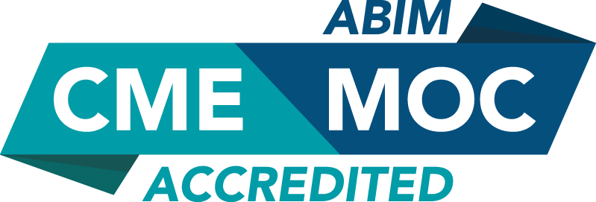

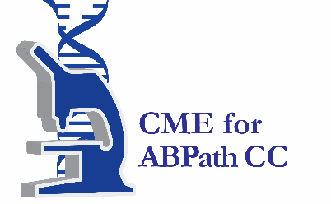

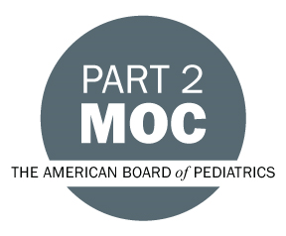

MOC Statement(s)

Successful completion of this CME activity ,enables the learner to earn credit toward the CME requirement(s) of the American Board of Surgery’s Continuous Certification program. It is the CME activity provider's responsibility to submit learner completion information to ACCME for the purpose of granting ABS credit.ABMS



Faculty & Planner Disclosures
University of California, Irvine School of Medicine Continuing Medical Education adheres to the ACCME’s Standards for Integrity and Independence in Accredited Continuing Education. Any individuals in a position to control the content of a CE activity, including faculty, planners, reviewers, or others are required to disclose all relevant financial relationships with ineligible entities (commercial interests). All relevant conflicts of interest have been mitigated prior to the commencement of the activity.

Name of individual | Individual's role in activity | Nature of Relationship(s) / Name of Ineligible Company(s)
Bianca M Gutierrez, BS | Activity Coordinator | Nothing to disclose - 01/09/2026
Frank Hsu, MD, PhD | Course Director | Ownership-AquaTex Medical |Grant or research support-Koh Young|Consulting Fee-Integra LifeSciences Corporation (Relationship has ended) - 04/14/2026
Alex Lopez, MD, MS | Planning Committee Member | Nothing to disclose - 07/06/2026
Jacques J. Morcos, MD | Faculty | Nothing to disclose - 08/03/2026
Michael Oh, MD | Faculty | Membership on Advisory Committees or Review Panels, Board Membership, etc.-2nd Skull|Consulting Fee-GS Medical|Membership on Advisory Committees or Review Panels, Board Membership, etc.-Intravent Medical - 04/21/2026
Cassie Poole, PA-C | Planning Committee Member | Nothing to disclose - 08/11/2026

Agenda
[INSERT AGENDA HERE MANUALLY]

Acknowledgement of Commercial Support
No commercial support has been received for this activity.

