18th Annual Orange County Symposium for Cardiovascular Disease Prevention

October 23, 2026

Purpose
The 18th Annual Orange County Symposium for Cardiovascular Disease Prevention is designed to address critical knowledge gaps in the rapidly evolving field of preventive cardiology. This educational program will provide primary care providers, cardiologists, endocrinologists, lifestyle interventionists, and other healthcare professionals with the latest evidence and practical strategies to improve cardiovascular health and reduce disease burden. Participants will receive updates on the role of large cohort studies in advancing precision nutrition; new insights from the Global Burden of Disease Study and their implications for population cardiometabolic health and public policy; the impact of micronutrients on cardiovascular disease prevention; and the relationship between stress, mind-body health, and cardiovascular outcomes. Additional topics include national nutrition recommendations for cardiovascular disease prevention, innovative models for cardiac rehabilitation, the spectrum and complications of cardiokidney metabolic syndrome, and evidence-based prevention strategies to reduce cardiovascular disease risk.
The symposium will also explore protocols for developing multidisciplinary cardiometabolic clinics, updated lipid management guidelines, and the role of lipoprotein(a) in cardiovascular risk assessment and prevention. Attendees will learn about the expanding role of GLP-1 receptor agonist therapies in diabetes, obesity, and cardiovascular risk reduction, as well as emerging therapies for diabetes management and their impact on preventing cardiovascular events. Further sessions will address women’s cardiovascular health, including ANOCA and microvascular disease, multimodal imaging in cardiac prevention, the relationship between alcohol consumption and cardiovascular disease, and other sessions addressing the latest strategies for CVD prevention. Through these diverse and timely topics, the symposium aims to equip healthcare professionals with the knowledge and tools needed to advance evidence-based cardiovascular disease prevention in clinical practice.
Programming will take place on Friday, October 23, 2026 from 11:00 a.m. - 6:00 p.m. and Saturday, October 24, 2026 from 8:20 a.m. – 4:00 p.m.

Target Audience
Specialties – Medicine, Cardiology, Endocrinology, General Internal Medicine & Primary Care, Nephrology, Hypertension & Kidney Transplantation
Professions – Physician, Non-Physician, Allied Health Professional, Medical Assistant, Medical Student, Nurse, Nurse Practitioner, Pharmacist, Physician Assistant, Registered Dietitian, Resident Physician

Activity Objectives
1 Clinicians and researchers will learn about the connection between and strategies for improving healthy lifestyles for prevention of cardiovascular disease.

2 Clinicians and researchers will learn about newer strategies for assessing cardiovascular and cardiometabolic risks.

3 Clinicians and researchers will learn about newer therapeutic options and guidelines for optimizing cardiovascular risk reduction.

Accreditation Statement
The University of California, Irvine School of Medicine is accredited by the Accreditation Council for Continuing Medical Education to provide continuing medical education for physicians.

Designation Statement
The University of California, Irvine School of Medicine designates this Live Activity for a maximum of 9.50 AMA PRA Category 1 Credit(s)™. Physicians should claim only the credit commensurate with the extent of their participation in the activity.

California Assembly Bill 1195 and 241
This activity is in compliance with California Assembly Bill 1195 and 241, which require CME activities with patient care components to include curriculum in the subjects of cultural and linguistic competency & implicit bias. It is the intent of AB 1195 and AB 241 to encourage physicians and surgeons, CME providers in the State of California, and the Accreditation Council for Continuing Medical Education to meet the cultural and linguistic concerns of a diverse patient population and reduce health disparities through appropriate professional development. Please see the CME website, https://www.meded.uci.edu/CME/ for AB 1195 and AB 241 resources.





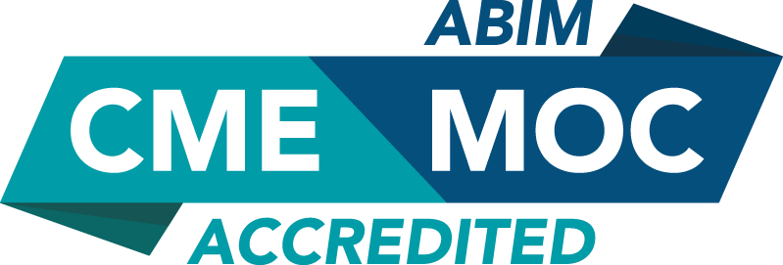

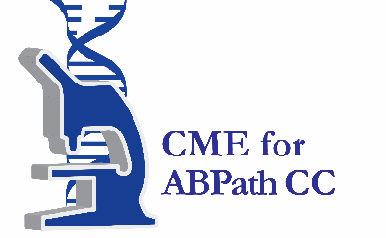

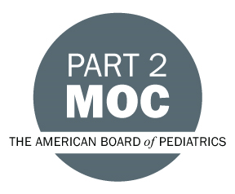

MOC Statement(s)

Successful completion of this CME activity, which includes participation in the evaluation component, enables the participant to earn up to 9.50 MOC point(s) in the American Board of Internal Medicine’s (ABIM) Maintenance of Certification (MOC) program. It is the CME activity provider’s responsibility to submit participant completion information to ACCME for the purpose of granting ABIM MOC credit.ABMS

Faculty & Planner Disclosures
University of California, Irvine School of Medicine Continuing Medical Education adheres to the ACCME’s Standards for Integrity and Independence in Accredited Continuing Education. Any individuals in a position to control the content of a CE activity, including faculty, planners, reviewers, or others are required to disclose all relevant financial relationships with ineligible entities (commercial interests). All relevant conflicts of interest have been mitigated prior to the commencement of the activity.

Name of individual | Individual's role in activity | Nature of Relationship(s) / Name of Ineligible Company(s)
Harpreet S. Bhatia, MD, MD, MAS, FACC, FAHA, FASPC | Faculty | Advisor-Arrowhead|Honoraria-Amgen|Consulting Fee-Merck (Any division)|Advisor-Novartis Corporation Pharmaceuticals|Advisor-NewAmsterdam|Advisor-Bayer (Any division) (Relationship has ended) - 06/26/2026
Efrain Cerrato, MBA | Faculty
Wenjun Fan, PhD | Faculty | Nothing to disclose - 03/02/2026
Yehuda Handelsman, MD | Faculty | Grant or research support-Corcept|Grant or research support-Ionis|Grant or research support-Merck (Any division)|Grant or research support-Regeneron Pharmaceuticals, Inc.|Grant or research support-Verdiva Bio|Consulting Fee-Amgen, Inc. (Relationship has ended)|Advisor-AstraZeneca (Any division)|Advisor-Bayer (Any division)|Advisor-Boehringer Ingelheim Pharmaceuticals, Inc.|Advisor-Corcept|Advisor-Regeneron Pharmaceuticals, Inc.|Advisor-Verdiva Bio|Honoraria-Novo Nordisk (Any division) - 06/15/2026
Frank B. Hu, MD, PhD | Faculty | Nothing to disclose - 06/15/2026
Sina Kianoush, MD, MPH | Faculty | Nothing to disclose - 02/10/2026
Simin Liu, MD, PhD | Co-Director, Faculty | Nothing to disclose - 03/09/2026
Shaista Malik, MD, PhD, MPH | Co-Director, Faculty | Ownership-FluxWear - 03/31/2026
Ali Mokdad, PhD | Faculty | Nothing to disclose - 06/24/2026
Pranav Patel, MD | Faculty | Nothing to disclose - 03/30/2026
Jamal S. Rana, MD, PhD | Faculty | Nothing to disclose - 10/28/2025
Paul Rosenblit, MD, PhD | Co-Director | Grant or research support-Novartis Corporation Pharmaceuticals|Grant or research support-Novo Nordisk (Any division)|Grant or research support-Ionis Pharmaceuticals - 04/01/2026
Paul D. Rosenblit, MD, PhD, FACE, FNLA | Faculty
Katherine Smith, BA | Activity Coordinator | Nothing to disclose - 01/13/2026
Laurence Sperling, MD | Faculty | Nothing to disclose - 01/21/2026
Janet Wei, MD, FACC, FAHA | Faculty | Grant or research support-Philips (Any division) (Relationship has ended) - 05/26/2026
Nathan D. Wong, PhD, MPH | Course Director, Faculty | Grant or research support-Novartis Corporation Pharmaceuticals|Consulting Fee-Novartis Corporation Pharmaceuticals|Consulting Fee-Amgen, Inc.|Consulting Fee-Ionis Pharmaceuticals|Grant or research support-Novo Nordisk (Any division) (Relationship has ended)|Consulting Fee-Heart Lung|Grant or research support-Amgen, Inc.|Speakers Bureau-Novartis Corporation Pharmaceuticals (Relationship has ended) - 03/09/2026
John W. Zamarra, MD | Faculty

Agenda
[INSERT AGENDA HERE MANUALLY]

Acknowledgement of Commercial Support
No commercial support has been received for this activity.

