2026 Business of Interprofessional Healthcare Conference: Collaboration in Action: Aligning Teams to Deliver Better Care

October 8, 2026

Purpose
Continuing discussions examining interprofessional practice and the transformative role of data and AI, the 2026 conference focuses on the practical implementation of team-based care—specifically, how collaboration functions in real-world clinical settings. Despite a shared commitment to patient-centered care, healthcare teams frequently encounter barriers including misaligned priorities, communication challenges, hierarchical dynamics, and gaps between training and practice. This conference aims to address these challenges by exploring the human and operational competencies that translate intention into effective team-based care. Through interdisciplinary dialogue, participants will gain actionable strategies to enhance communication, clarify roles, foster accountability, and navigate competing demands, ultimately strengthening collaboration and improving patient outcomes.

Target Audience
Specialties – Anesthesiology & Perioperative Care, Dermatology, Emergency Medicine, Family Medicine, Medicine, Neurological Surgery, Neurology, Obstetrics & Gynecology, Ophthalmology, Orthopaedic Surgery, Otolaryngology - Head & Neck Surgery, Pathology & Laboratory Medicine, Pediatrics, Physical Medicine & Rehabilitation, Plastic Surgery, Psychiatry & Human Behavior, Radiation Oncology, Radiological Sciences, Surgery, Urology, Other
Professions – Physician, Allied Health Professional, Nurse, Nurse Practitioner, Other, Pharmacist, Physician Assistant, Resident Physician

Activity Objectives
1 Identify common barriers to effective interprofessional collaboration, including role ambiguity, communication breakdowns, and misaligned priorities

2 Examine how hierarchy, bias, and professional identity influence team dynamics and decision-making
3 Describe the evolving roles of key health professions, including nursing, pharmacy, medicine, public health and integrative health

4 Apply practical communication strategies to improve collaboration in real-world care settings
5 Implement at least one actionable strategy to strengthen interprofessional collaboration in their own work environment

Accreditation Statement
This activity has been planned and implemented in accordance with the accreditation requirements and policies of the Accreditation Council for Continuing Medical Education (ACCME) through the joint providership of the University of California, Irvine School of Medicine and UCI COHS . The University of California, Irvine School of Medicine is accredited by the ACCME to provide continuing medical education for physicians. to provide continuing medical education for physicians.

Designation Statement
The University of California, Irvine School of Medicine designates this Live Activity for a maximum of 2.50 AMA PRA Category 1 Credit(s)™. Physicians should claim only the credit commensurate with the extent of their participation in the activity.

California Assembly Bill 1195 and 241
This activity is in compliance with California Assembly Bill 1195 and 241, which require CME activities with patient care components to include curriculum in the subjects of cultural and linguistic competency & implicit bias. It is the intent of AB 1195 and AB 241 to encourage physicians and surgeons, CME providers in the State of California, and the Accreditation Council for Continuing Medical Education to meet the cultural and linguistic concerns of a diverse patient population and reduce health disparities through appropriate professional development. Please see the CME website, https://www.meded.uci.edu/CME/ for AB 1195 and AB 241 resources.



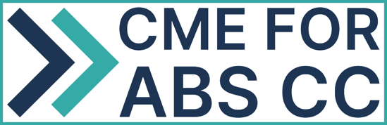

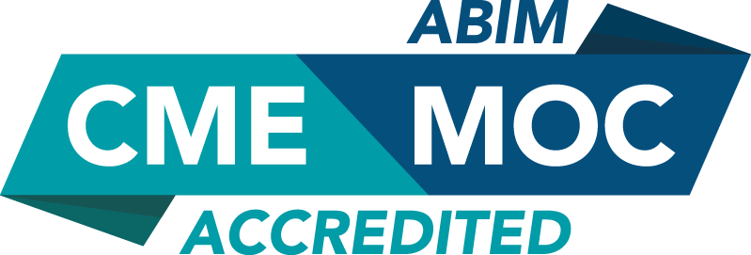

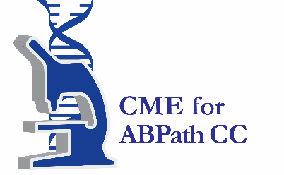

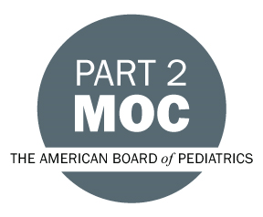

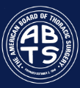

Faculty & Planner Disclosures
University of California, Irvine School of Medicine Continuing Medical Education adheres to the ACCME’s Standards for Integrity and Independence in Accredited Continuing Education. Any individuals in a position to control the content of a CE activity, including faculty, planners, reviewers, or others are required to disclose all relevant financial relationships with ineligible entities (commercial interests). All relevant conflicts of interest have been mitigated prior to the commencement of the activity.

Name of individual | Individual's role in activity | Nature of Relationship(s) / Name of Ineligible Company(s)
Richard Afable, MPH | Faculty | Nothing to disclose - 08/24/2026
Bernadette Boden-Albala, DrPH | Faculty | Nothing to disclose - 08/05/2026
Joseph C. Carmichael, MD | Faculty | Nothing to disclose - 02/23/2026
Arvin Jenab, ND, ND | Faculty | Nothing to disclose - 05/05/2026
Sarah McBane, PharmD | Faculty | Nothing to disclose - 08/06/2026
Nimisha K Parekh, MD | Faculty | Nothing to disclose - 08/01/2026
Susanne J Phillips, NP, FAANP, FAAN | Faculty | Nothing to disclose - 08/28/2026
Michael Stamos, MD | Faculty | Nothing to disclose - 01/06/2026
Candice E Whealon, NP | Course Director, Faculty | Nothing to disclose - 08/10/2026

Agenda
[INSERT AGENDA HERE MANUALLY]

Acknowledgement of Commercial Support
No commercial support has been received for this activity.

