UC Irvine Comprehensive Stroke Symposium: Recent Advances and Innovations in Stroke Care and Research

October 10, 2026

Purpose
The UC Irvine School of Medicine Comprehensive Stroke Symposium offers an update on the latest advances in stroke care and research. Acute stroke care requires a multidisciplinary approach by a group of highly trained specialists, including neuroradiologist, stroke neurologist, neurointerventional surgeon, neurosurgeon, and neurointensivist. This conference is designed to improve the knowledge and performance of healthcare providers for patients with acute stroke and other cerebrovascular diseases.

Target Audience
Professions – Physician, Non-Physician, Allied Health Professional, EMT, Medical Student, Nurse, Nurse Practitioner, Paramedic, Pharmacist, Physical Therapist, Physician Assistant, Resident Physician, Clinical Social Worker, Speech-Language Pathologist, Occupational Therapist

Activity Objectives
1 Describe the latest evidence-based guidelines for ischemic and hemorrhagic stroke management.
2 Summarize advances in thrombolytic and mechanical therapy for acute ischemic stroke.
3 Describe recent advances of neurosurgical interventions for cerebrovascular disease.
4 Appraise the innovations of stroke care and research

Accreditation Statement
The University of California, Irvine School of Medicine is accredited by the Accreditation Council for Continuing Medical Education to provide continuing medical education for physicians.

Designation Statement
The University of California, Irvine School of Medicine designates this Live Activity for a maximum of 6.50 AMA PRA Category 1 Credit(s)™. Physicians should claim only the credit commensurate with the extent of their participation in the activity.

California Assembly Bill 1195 and 241
This activity is in compliance with California Assembly Bill 1195 and 241, which require CME activities with patient care components to include curriculum in the subjects of cultural and linguistic competency & implicit bias. It is the intent of AB 1195 and AB 241 to encourage physicians and surgeons, CME providers in the State of California, and the Accreditation Council for Continuing Medical Education to meet the cultural and linguistic concerns of a diverse patient population and reduce health disparities through appropriate professional development. Please see the CME website, https://www.meded.uci.edu/CME/ for AB 1195 and AB 241 resources.





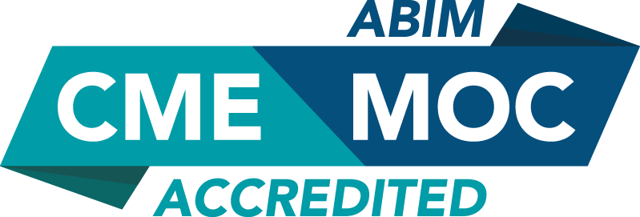

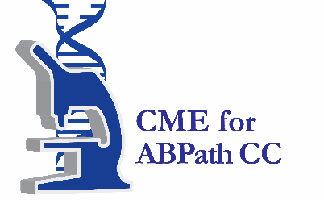

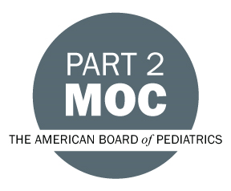

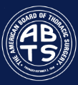

Faculty & Planner Disclosures
University of California, Irvine School of Medicine Continuing Medical Education adheres to the ACCME’s Standards for Integrity and Independence in Accredited Continuing Education. Any individuals in a position to control the content of a CE activity, including faculty, planners, reviewers, or others are required to disclose all relevant financial relationships with ineligible entities (commercial interests). All relevant conflicts of interest have been mitigated prior to the commencement of the activity.

Name of individual | Individual's role in activity | Nature of Relationship(s) / Name of Ineligible Company(s)
Yama Akbari, MD, PhD | Faculty | Grant or research support-Hamamatsu Photonics KK|Grant or research support-Ceribell - 03/17/2026
Jefferson W Chen, MD, PhD | Faculty | Nothing to disclose - 10/16/2025
Mark Fisher, MD | Faculty | Nothing to disclose - 08/06/2026
David Fussell, MD | Faculty | Nothing to disclose - 08/17/2026
Kiarash Golshani, MD | Faculty | Nothing to disclose - 07/10/2026
Frank Hsu, MD, PhD | Co-Director, Faculty | Ownership-AquaTex Medical |Grant or research support-Koh Young - 04/14/2026
Michael Kim, MD | Faculty | Nothing to disclose - 08/06/2026
Andrew J Lee, MD | Faculty | Nothing to disclose - 06/24/2026
Jacques J. Morcos, MD | Faculty | Nothing to disclose - 08/03/2026
Masaki Nagamine, MD | Faculty | Nothing to disclose - 06/29/2026
Nirav S Patel, MD | Faculty | Speakers Bureau-Lundbeck, Inc. - 08/11/2026
Ahmad Riad Ramadan, MD | Faculty | Nothing to disclose - 08/11/2026
S. Mohammad H Shafie, MD, PhD | Faculty | Nothing to disclose - 06/17/2026
Jay Shah, MD | Faculty | Nothing to disclose - 06/29/2026
Jennifer Soun, MD | Faculty | Nothing to disclose - 08/24/2026
Sara Stern-Nezer, MD, MPH | Faculty | Nothing to disclose - 05/20/2026
Shuichi Suzuki, MD, PhD | Faculty | Nothing to disclose - 09/28/2026
Stewart Weber, MD | Faculty | Nothing to disclose - 08/07/2026
Wengui Yu, MD, PhD | Co-Director, Faculty | Nothing to disclose - 09/16/2026
Ichiro Yuki, MD | Faculty | Ownership-AquaTeX Medical - 03/25/2026

Agenda
[INSERT AGENDA HERE MANUALLY]

Acknowledgement of Commercial Support
No commercial support has been received for this activity.

