2026 Facial Rejuvenation and Aesthetics Conference

August 22, 2026

Purpose
This course is designed to provide a comprehensive, stepwise approach to facial rejuvenation, spanning the full spectrum from novice to expert. Foundational principles will be emphasized for those early in their experience, while advanced techniques and nuanced decision-making will be highlighted for the experienced surgeon. Special topics will include the use of injectables (neuromodulators and fillers), surgical rejuvenation procedures, energy-based devices, and adjunctive office-based interventions. Exhibitors will be in attendance to demonstrate the latest technologies and innovations relevant to both surgical and non-surgical facial rejuvenation.

Target Audience
Specialties – Dermatology, Otolaryngology - Head & Neck Surgery, Plastic Surgery
Professions – Physician, Allied Health Professional, Medical Assistant, Medical Student, Nurse, Nurse Practitioner, Physician Assistant, Resident Physician

Activity Objectives
1 Analyze facial anatomy, aging physiology, and aesthetic principles as they relate to facial rejuvenation, and apply this knowledge to develop individualized treatment plans that achieve natural, balanced, and patient-specific outcomes.
2 Apply contemporary surgical and non-surgical facial rejuvenation techniques—including facelift, blepharoplasty, brow lift, facial contouring, injectables, and energy-based therapies—using stepwise procedural strategies and integrated, multimodal treatment approaches.
3 Evaluate and manage routine and complex facial rejuvenation cases, including revision procedures, by integrating advanced clinical judgment, patient-specific factors, and patient-centered care principles to optimize outcomes.

Accreditation Statement
The University of California, Irvine School of Medicine is accredited by the Accreditation Council for Continuing Medical Education to provide continuing medical education for physicians.

Designation Statement
The University of California, Irvine School of Medicine designates this Live Activity for a maximum of 16.00 AMA PRA Category 1 Credit(s)™. Physicians should claim only the credit commensurate with the extent of their participation in the activity.

California Assembly Bill 1195 and 241
This activity is in compliance with California Assembly Bill 1195 and 241, which require CME activities with patient care components to include curriculum in the subjects of cultural and linguistic competency & implicit bias. It is the intent of AB 1195 and AB 241 to encourage physicians and surgeons, CME providers in the State of California, and the Accreditation Council for Continuing Medical Education to meet the cultural and linguistic concerns of a diverse patient population and reduce health disparities through appropriate professional development. Please see the CME website, https://www.meded.uci.edu/CME/ for AB 1195 and AB 241 resources.





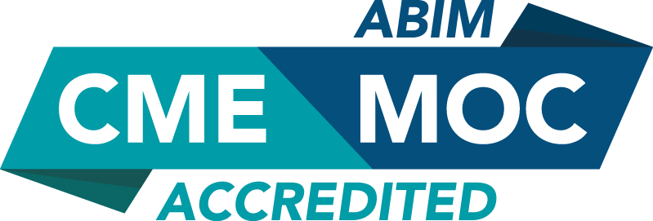

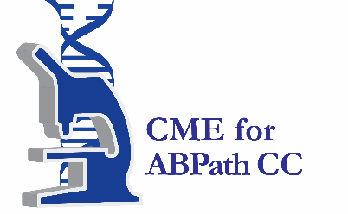

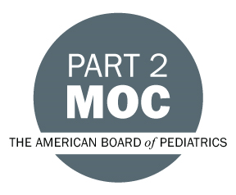

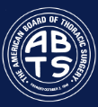

Faculty & Planner Disclosures
University of California, Irvine School of Medicine Continuing Medical Education adheres to the ACCME’s Standards for Integrity and Independence in Accredited Continuing Education. Any individuals in a position to control the content of a CE activity, including faculty, planners, reviewers, or others are required to disclose all relevant financial relationships with ineligible entities (commercial interests). All relevant conflicts of interest have been mitigated prior to the commencement of the activity.

Name of individual | Individual's role in activity | Nature of Relationship(s) / Name of Ineligible Company(s)
Babak Azizzadeh, MD | Faculty
Jacob Boeckmann, MD | Faculty | Nothing to disclose - 08/04/2026
Bryan Brandon, MD | Faculty | Nothing to disclose - 10/06/2025
Harry H Ching, MD | Faculty
James Newman, MD | Faculty
Grace L Peng, MD, F.A.C.S. | Faculty
Rebecca Reynolds, MD | Faculty
Rebecca Reynolds, MD | Faculty
Jonathan Sykes, MD | Faculty
Brian Wong, MD | Course Director, Faculty | Nothing to disclose - 07/01/2026

Agenda
[INSERT AGENDA HERE MANUALLY]

Acknowledgement of Commercial Support
No commercial support has been received for this activity.

