Psychiatry & Psychotherapy Podcast Series: Episode 266: Understanding Mature Defense Mechanisms in Psychotherapy: Framework with Clinical Examples from the Tuesday Cohort

May 26, 2026 – June 13, 2029

Purpose
Through clinical teaching, case vignettes, group discussion, and real-time cohort reflection, participants will learn to identify and understand defenses such as denial, splitting, projection, projective identification, dissociation, enactment, somatization, and more. Emphasis is placed on developmental origins, adaptive vs. maladaptive functions, and the impact of defenses on the therapeutic relationship, including countertransference.
This course highlights practical clinical application while showcasing the collaborative learning and clinical insight of an advanced psychotherapy training group.

Target Audience
Specialties – Family Medicine, Medicine, Psychiatry & Human Behavior

Activity Objectives
1 Cite and differentiate key primitive (immature) psychological defenses:
2 Analyze the adaptive versus maladaptive functions of these defenses in clinical and everyday contexts
3 Apply concepts of primitive defenses to improve clinical observation, countertransference awareness, and therapeutic practice

Accreditation Statement
This activity has been planned and implemented in accordance with the accreditation requirements and policies of the Accreditation Council for Continuing Medical Education (ACCME) through the joint providership of the University of California, Irvine School of Medicine and Emotion Connection, LLC. The University of California, Irvine School of Medicine is accredited by the ACCME to provide continuing medical education for physicians. to provide continuing medical education for physicians.

Designation Statement
The University of California, Irvine School of Medicine designates this Enduring Material for a maximum of 2.50 AMA PRA Category 1 Credit(s)™. Physicians should claim only the credit commensurate with the extent of their participation in the activity.

California Assembly Bill 1195 and 241
This activity is in compliance with California Assembly Bill 1195 and 241, which require CME activities with patient care components to include curriculum in the subjects of cultural and linguistic competency & implicit bias. It is the intent of AB 1195 and AB 241 to encourage physicians and surgeons, CME providers in the State of California, and the Accreditation Council for Continuing Medical Education to meet the cultural and linguistic concerns of a diverse patient population and reduce health disparities through appropriate professional development. Please see the CME website, https://www.meded.uci.edu/CME/ for AB 1195 and AB 241 resources.







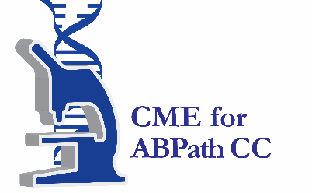

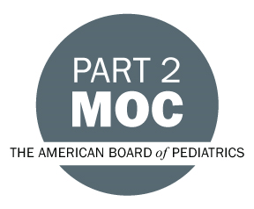

Faculty & Planner Disclosures
University of California, Irvine School of Medicine Continuing Medical Education adheres to the ACCME’s Standards for Integrity and Independence in Accredited Continuing Education. Any individuals in a position to control the content of a CE activity, including faculty, planners, reviewers, or others are required to disclose all relevant financial relationships with ineligible entities (commercial interests). All relevant conflicts of interest have been mitigated prior to the commencement of the activity.

Name of individual | Individual's role in activity | Nature of Relationship(s) / Name of Ineligible Company(s)
Joanie Burns, Other, DNP, APRN, PMHNP-BC | Other Planning Committee Member | Nothing to disclose - 01/04/2026
Chris DiDonna, MA | Faculty | Nothing to disclose - 05/04/2026
Natalie Dreyfoos, Other | Faculty | Nothing to disclose - 05/04/2026
Deana Goldin, Other | Faculty | Nothing to disclose - 05/04/2026
Jeanette Houghtelling, APRN | Faculty | Nothing to disclose - 05/21/2026
Jason Kent, Other | Faculty | Nothing to disclose - 05/04/2026
Annabel Kuhn, MD | Other Planning Committee Member | Nothing to disclose - 01/05/2026
Olga Kuznetsova, Other | Faculty | Nothing to disclose - 05/04/2026
Charles Mallo, DO | Faculty | Nothing to disclose - 05/04/2026
Littal Melnik, Other | Faculty | Nothing to disclose - 05/04/2026
David Puder, MD | Faculty | Nothing to disclose - 12/21/2025
Katia Ronay, Other | Faculty | Nothing to disclose - 05/21/2026
Amanda Sekijima, Other | Faculty | Nothing to disclose - 05/04/2026

Agenda
[INSERT AGENDA HERE MANUALLY]

Acknowledgement of Commercial Support
No commercial support has been received for this activity.

