UC Irvine Susan Samueli Integrative Health Institute Wellbeing Grand Rounds
I've Got You; Reclaiming Civility, Connection, and Joy in Medicine

September 30, 2026

Purpose
Wellbeing grand rounds is sponsored by the Samueli Office of Wellbeing. This activity combines education on organizational and individual interventions that can reduce provider burnout and improve wellbeing, which directly relates to improved patient care. This is a space for education and open dialogue for clinicians.
Objective(s): 1 Identify organizational factors that contribute to clinician burnout and describe evidence-based strategies to address them. 2 Recognize individual factors associated with clinician burnout and discuss approaches to promote resilience and well-being. 3 Locate and utilize institutional resources available at UCI to support clinician wellness and professional fulfillment. 4 Evaluate the impact of the electronic medical record (EMR) on clinician burnout and identify strategies to optimize EMR use and reduce burden. 5 Create a supportive space for clinicians to share difficult situations and challenging interactions
Location: Teleconference
Specialties: Anesthesiology & Perioperative Care, Dermatology, Emergency Medicine, Family Medicine, Medicine, Neurological Surgery, Neurology, Obstetrics & Gynecology, Ophthalmology, Orthopaedic Surgery, Otolaryngology - Head & Neck Surgery, Pathology & Laboratory Medicine, Pediatrics, Physical Medicine & Rehabilitation, Plastic Surgery, Psychiatry & Human Behavior, Radiation Oncology, Radiological Sciences, Surgery, Urology, Other
Faculty Disclosures:
John C. Fox, MD (Nothing to disclose - 12/22/2025)
Download Handout

Target Audience
Specialties – Anesthesiology & Perioperative Care, Dermatology, Emergency Medicine, Family Medicine, Medicine, Neurological Surgery, Neurology, Obstetrics & Gynecology, Ophthalmology, Orthopaedic Surgery, Otolaryngology - Head & Neck Surgery, Pathology & Laboratory Medicine, Pediatrics, Physical Medicine & Rehabilitation, Plastic Surgery, Psychiatry & Human Behavior, Radiation Oncology, Radiological Sciences, Surgery, Urology, Other
Professions – Physician, Allied Health Professional, Medical Assistant, Medical Student, Nurse, Nurse Practitioner, Pharmacist, Physician Assistant, Resident Physician, Clinical Social Worker

Activity Objectives
1 Identify organizational factors that contribute to clinician burnout and describe evidence-based strategies to address them.

2 Recognize individual factors associated with clinician burnout and discuss approaches to promote resilience and well-being.
3 Locate and utilize institutional resources available at UCI to support clinician wellness and professional fulfillment.
4 Evaluate the impact of the electronic medical record (EMR) on clinician burnout and identify strategies to optimize EMR use and reduce burden.
5 Create a supportive space for clinicians to share difficult situations and challenging interactions

Accreditation Statement
This activity has been planned and implemented in accordance with the accreditation requirements and policies of the Accreditation Council for Continuing Medical Education (ACCME) through the joint providership of the University of California, Irvine School of Medicine and UCI Health Susan Samueli Integrative Health Institute. The University of California, Irvine School of Medicine is accredited by the ACCME to provide continuing medical education for physicians. to provide continuing medical education for physicians.

Designation Statement
The University of California, Irvine School of Medicine designates this Live Activity for a maximum of 1.00 AMA PRA Category 1 Credit(s)™. Physicians should claim only the credit commensurate with the extent of their participation in the activity.

California Assembly Bill 1195 and 241
This activity is in compliance with California Assembly Bill 1195 and 241, which require CME activities with patient care components to include curriculum in the subjects of cultural and linguistic competency & implicit bias. It is the intent of AB 1195 and AB 241 to encourage physicians and surgeons, CME providers in the State of California, and the Accreditation Council for Continuing Medical Education to meet the cultural and linguistic concerns of a diverse patient population and reduce health disparities through appropriate professional development. Please see the CME website, https://www.meded.uci.edu/CME/ for AB 1195 and AB 241 resources.





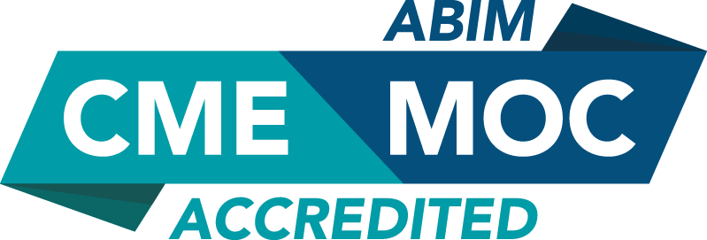



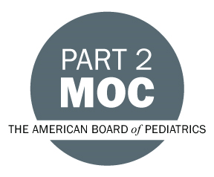

MOC Statement(s)

Successful completion of this CME activity ,enables the learner to earn credit toward the CME requirement(s) of the American Board of Surgery’s Continuous Certification program. It is the CME activity provider's responsibility to submit learner completion information to ACCME for the purpose of granting ABS credit.ABMS



Faculty & Planner Disclosures
University of California, Irvine School of Medicine Continuing Medical Education adheres to the ACCME’s Standards for Integrity and Independence in Accredited Continuing Education. Any individuals in a position to control the content of a CE activity, including faculty, planners, reviewers, or others are required to disclose all relevant financial relationships with ineligible entities (commercial interests). All relevant conflicts of interest have been mitigated prior to the commencement of the activity.

Name of individual | Individual's role in activity | Nature of Relationship(s) / Name of Ineligible Company(s)
John C. Fox, MD | Faculty | Nothing to disclose - 12/22/2025
Anju Hurria, MD | Course Director | Nothing to disclose - 08/06/2026
Laurie Skorheim, Other | Activity Coordinator | Nothing to disclose - 07/30/2026

Agenda
[INSERT AGENDA HERE MANUALLY]

Acknowledgement of Commercial Support
No commercial support has been received for this activity.

