Psychiatry & Psychotherapy Podcast Series: Episode 279: Postpartum Depression and Problem-Focused Psychodynamic Psychotherapy: Understanding the Five Core Conflicts

September 15, 2026

Purpose
Explore postpartum depression and the role of psychotherapy with psychiatrists Dr. Alyson Gorun and Dr. Fredric Busch, co-authors of a book on postpartum problem-focused psychodynamic psychotherapy.

Target Audience
Specialties – Family Medicine, Medicine, Psychiatry & Human Behavior

Activity Objectives
1 Identify key psychological and interpersonal conflicts that may contribute to postpartum depression, anxiety, and difficulties in the transition to parenthood, including anger, idealized expectations, dependence, separation, and intrusion.
2 Apply a biopsychosocial and psychodynamic framework to the assessment and treatment of postpartum mental health concerns, incorporating attachment, cultural and social factors, mentalization, and evidence-based interventions.
3 Recognize how shame, intrusive thoughts, relationship difficulties, emotional dysregulation, and clinician countertransference can influence postpartum psychotherapy and develop strategies for addressing these issues therapeutically.

Accreditation Statement
This activity has been planned and implemented in accordance with the accreditation requirements and policies of the Accreditation Council for Continuing Medical Education (ACCME) through the joint providership of the University of California, Irvine School of Medicine and Emotion Connection, LLC. The University of California, Irvine School of Medicine is accredited by the ACCME to provide continuing medical education for physicians. to provide continuing medical education for physicians.

Designation Statement
The University of California, Irvine School of Medicine designates this Enduring Material for a maximum of 1.25 AMA PRA Category 1 Credit(s)™. Physicians should claim only the credit commensurate with the extent of their participation in the activity.

California Assembly Bill 1195 and 241
This activity is in compliance with California Assembly Bill 1195 and 241, which require CME activities with patient care components to include curriculum in the subjects of cultural and linguistic competency & implicit bias. It is the intent of AB 1195 and AB 241 to encourage physicians and surgeons, CME providers in the State of California, and the Accreditation Council for Continuing Medical Education to meet the cultural and linguistic concerns of a diverse patient population and reduce health disparities through appropriate professional development. Please see the CME website, https://www.meded.uci.edu/CME/ for AB 1195 and AB 241 resources.







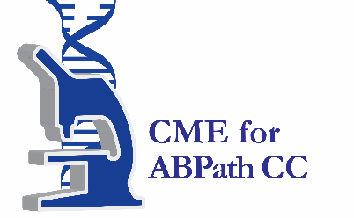

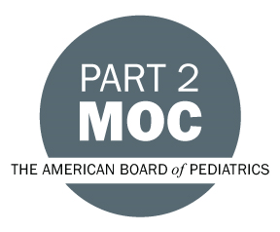



Faculty & Planner Disclosures
University of California, Irvine School of Medicine Continuing Medical Education adheres to the ACCME’s Standards for Integrity and Independence in Accredited Continuing Education. Any individuals in a position to control the content of a CE activity, including faculty, planners, reviewers, or others are required to disclose all relevant financial relationships with ineligible entities (commercial interests). All relevant conflicts of interest have been mitigated prior to the commencement of the activity.

Name of individual | Individual's role in activity | Nature of Relationship(s) / Name of Ineligible Company(s)
Fredric N Busch, MD | Faculty | Nothing to disclose - 04/10/2026
Alyson Gorun, MD | Faculty | Nothing to disclose - 08/31/2026
Jonathan Nowlin, MS | Planning Committee Member | Nothing to disclose - 01/02/2026
David Puder, MD | Course Director, Faculty | Nothing to disclose - 09/01/2026

Agenda
[INSERT AGENDA HERE MANUALLY]

Acknowledgement of Commercial Support
No commercial support has been received for this activity.

