UCI HoLEP Masterclass: Holmium Laser Enucleation of the Prostate

February 19, 2026

Purpose
Accumulating evidence shows that holmium laser enucleation of the prostate (HoLEP) is associated with more favorable outcomes than other endoscopic approaches including shorter hospital stay, reduced bleeding complications, and shorter catheterization time. Moreover, HoLEP is not limited by size of the prostate i.e., size independent endoscopic treatment modality. Despite the above advantages, the long learning curve estimated to range from 30-50 cases hinders the wide adoption of this technique.

Target Audience
Specialties – Urology
Professions – Physician, Non-Physician, Medical Student, Nurse, Nurse Practitioner, Physician Assistant, Resident Physician

Activity Objectives
1 Identify the psychomotor skills and cognitive knowledge required to perform a laser enucleation of the prostate procedure from experts in the field.
2 Complete 3 full HoLEP procedures on simulation hydrogel models.
3 Engage in discussions with an expert panel to master ‘tips & tricks’ of laser enucleation of the prostate.

Accreditation Statement
The University of California, Irvine School of Medicine is accredited by the Accreditation Council for Continuing Medical Education to provide continuing medical education for physicians.

Designation Statement
The University of California, Irvine School of Medicine designates this Live Activity for a maximum of 20.00 AMA PRA Category 1 Credit(s)™. Physicians should claim only the credit commensurate with the extent of their participation in the activity.

California Assembly Bill 1195 and 241
This activity is in compliance with California Assembly Bill 1195 and 241, which require CME activities with patient care components to include curriculum in the subjects of cultural and linguistic competency & implicit bias. It is the intent of AB 1195 and AB 241 to encourage physicians and surgeons, CME providers in the State of California, and the Accreditation Council for Continuing Medical Education to meet the cultural and linguistic concerns of a diverse patient population and reduce health disparities through appropriate professional development. Please see the CME website, https://www.meded.uci.edu/CME/ for AB 1195 and AB 241 resources.





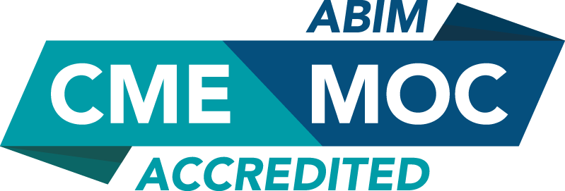

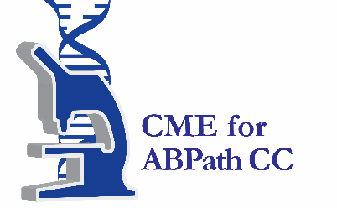

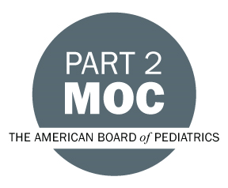

Faculty & Planner Disclosures
University of California, Irvine School of Medicine Continuing Medical Education adheres to the ACCME’s Standards for Integrity and Independence in Accredited Continuing Education. Any individuals in a position to control the content of a CE activity, including faculty, planners, reviewers, or others are required to disclose all relevant financial relationships with ineligible entities (commercial interests). All relevant conflicts of interest have been mitigated prior to the commencement of the activity.

Name of individual | Individual's role in activity | Nature of Relationship(s) / Name of Ineligible Company(s)
Sasha Orpilla-Advani, Other | Activity Coordinator | Nothing to disclose - 04/11/2025
Akhil Das, MD | Course Director | Nothing to disclose - 05/07/2025

Agenda
[INSERT AGENDA HERE MANUALLY]

Acknowledgement of Commercial Support
No commercial support has been received for this activity.

