UC Irvine Advanced International Men’s Health Course

January 24, 2026

Purpose
This two-day virtual course will cover specialized training for men’s health urologists, urinary incontinence specialists, andrology specialists and women's sexual dysfunction.

Target Audience
Specialties – Urology
Professions – Physician, Non-Physician, Medical Student, Nurse, Nurse Practitioner, Physician Assistant, Resident Physician

Activity Objectives
1 Diagnose, work up and manage patients with various Men’s Health conditions
(erectile dysfunction, ejaculatory dysfunction, hypogonadism, voiding dysfunction
and incontinence).
2 Understand how to work up and manage a couple with male-factor infertility.
3 Understand how to manage complications and controversies associated with
hypogonadism, such as prostate cancer, cardiovascular disease, and male infertility.
4 Prepare and set up, as well as perform standard and complex procedures, and
manage complications related to Peyronie’s disease, penile prosthesis and male
continence surgery.
5 Be familiar and comfortable with how to perform minimally invasive procedures and
surgeries for BPH.
6 Learn how to manage chronic orchalgia and pelvic floor dysfunction.
7 Learn the basics of the work up and management of female sexual dysfunction.

Accreditation Statement
The University of California, Irvine School of Medicine is accredited by the Accreditation Council for Continuing Medical Education to provide continuing medical education for physicians.

Designation Statement
The University of California, Irvine School of Medicine designates this Live Activity for a maximum of 21.00 AMA PRA Category 1 Credit(s)™. Physicians should claim only the credit commensurate with the extent of their participation in the activity.

California Assembly Bill 1195 and 241
This activity is in compliance with California Assembly Bill 1195 and 241, which require CME activities with patient care components to include curriculum in the subjects of cultural and linguistic competency & implicit bias. It is the intent of AB 1195 and AB 241 to encourage physicians and surgeons, CME providers in the State of California, and the Accreditation Council for Continuing Medical Education to meet the cultural and linguistic concerns of a diverse patient population and reduce health disparities through appropriate professional development. Please see the CME website, https://www.meded.uci.edu/CME/ for AB 1195 and AB 241 resources.





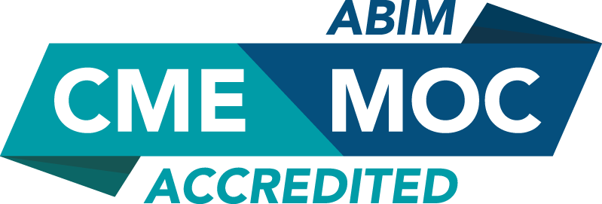

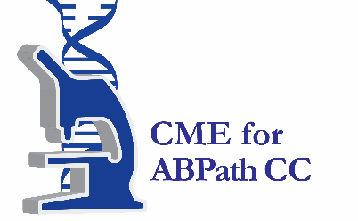

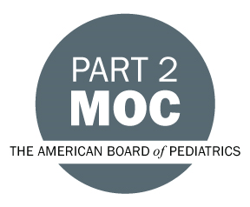

Faculty & Planner Disclosures
University of California, Irvine School of Medicine Continuing Medical Education adheres to the ACCME’s Standards for Integrity and Independence in Accredited Continuing Education. Any individuals in a position to control the content of a CE activity, including faculty, planners, reviewers, or others are required to disclose all relevant financial relationships with ineligible entities (commercial interests). All relevant conflicts of interest have been mitigated prior to the commencement of the activity.

Name of individual | Individual's role in activity | Nature of Relationship(s) / Name of Ineligible Company(s)
Sasha Orpilla-Advani, Other | Activity Coordinator | Nothing to disclose - 04/11/2025
Muhammed Alaa Moukhtar Hammad, MBBS | Co-Director | Nothing to disclose - 04/11/2025
Olivia Chang, MD, MPH | Co-Director | Nothing to disclose - 05/05/2025
Mohit Khera, MD, MBA | Co-Director | Advisor-AbbVie (Any division) (Relationship has ended)|Advisor-Endo Pharmaceuticals, Inc.|Advisor-Boston Scientific Corporation|Paid consultant-Marius|Paid consultant-Verity |Grant or research support-Ohhmed|Paid consultant-Hallozyme - 05/20/2025
Faysal A Yafi, MD, FRCSC | Course Director | Speakers Bureau-Coloplast|Advisor-Coloplast|Speakers Bureau-Halozyme|Consulting Fee-Sprout|Consulting Fee-Cynosure (Relationship has ended)|Consulting Fee-Amneal|Advisor-Endo Pharmaceuticals, Inc.|Advisor-Haleon - 05/19/2025
Lawrence Jenkins, MD, MBA, FACS | Co-Director | Membership on Advisory Committees or Review Panels, Board Membership, etc.-Sexual Medicine Society of North America |Consulting Fee-Coloplast (Relationship has ended) - 04/29/2025
Akhil Das, MD | Co-Director | Honoraria-Boston Scientific Corporation (Relationship has ended) - 05/07/2025
Mike Hsieh, MD | Co-Director | Honoraria-Boston Scientific Corporation - 05/16/2025
Gamal Ghoniem, MD | Course Director | Paid consultant-Rebecca tech|Consulting Fee-Laborie|Advisor-Bright Uro|Stocks or stock options, excluding diversified mutual funds-Bright Uro|Grant or research support-Inmode - 03/21/2025
David Barham, MD | Co-Director | Nothing to disclose - 04/29/2025
Jay Simhan, MD | Co-Director | Consulting Fee-Boston Scientific Corporation|Consulting Fee-Coloplast - 05/10/2025
Martin S. Gross, MD | Co-Director | Paid consultant-Coloplast|Paid consultant-MenMD - 05/27/2025
Jessica Yih, MD | Faculty | Nothing to disclose - 05/02/2025

Agenda
[INSERT AGENDA HERE MANUALLY]

Acknowledgement of Commercial Support
No commercial support has been received for this activity.

