Dermatitis Journal-Based CME
Dermatitis® July/August Issue

July 1, 2025 – August 31, 2025

Purpose
Dermatitis is the official journal of the ACDS. Through the society, the journal provides clear clinical guidance, consensus statements, requirements on best practice, etc. to dermatologists, allergists, immunologists, and toxicologists. Through this activity participants will have successfully completed self-assessment quiz associated with Dermatitis issues.

Target Audience
Specialties – Dermatology
Professions – Physician, Resident Physician

Activity Objectives
1 Apply the knowledge gained through the articles toward patient care
2 Demonstrate the understanding of the new advances in the field.

Accreditation Statement
This activity has been planned and implemented in accordance with the accreditation requirements and policies of the Accreditation Council for Continuing Medical Education (ACCME) through the joint providership of the University of California, Irvine School of Medicine and Mary Ann Liebert, Inc. - Journal of Dermatitis. The University of California, Irvine School of Medicine is accredited by the ACCME to provide continuing medical education for physicians. to provide continuing medical education for physicians.

Designation Statement
The University of California, Irvine School of Medicine designates this Journal-based CME activity for a maximum of 1.00 AMA PRA Category 1 Credit(s)™. Physicians should claim only the credit commensurate with the extent of their participation in the activity.

California Assembly Bill 1195 and 241
This activity is in compliance with California Assembly Bill 1195 and 241, which require CME activities with patient care components to include curriculum in the subjects of cultural and linguistic competency & implicit bias. It is the intent of AB 1195 and AB 241 to encourage physicians and surgeons, CME providers in the State of California, and the Accreditation Council for Continuing Medical Education to meet the cultural and linguistic concerns of a diverse patient population and reduce health disparities through appropriate professional development. Please see the CME website, https://www.meded.uci.edu/CME/ for AB 1195 and AB 241 resources.





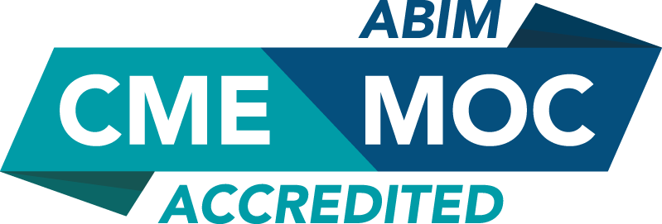

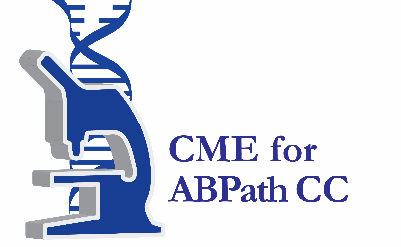

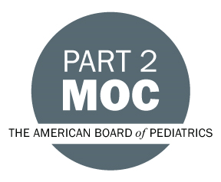

Faculty & Planner Disclosures
University of California, Irvine School of Medicine Continuing Medical Education adheres to the ACCME’s Standards for Integrity and Independence in Accredited Continuing Education. Any individuals in a position to control the content of a CE activity, including faculty, planners, reviewers, or others are required to disclose all relevant financial relationships with ineligible entities (commercial interests). All relevant conflicts of interest have been mitigated prior to the commencement of the activity.

Name of individual | Individual's role in activity | Nature of Relationship(s) / Name of Ineligible Company(s)
Jo Urquhart | Activity Administrator | Nothing to disclose - 02/05/2025
Anthony Gaspari, MD | Course Director | Nothing to disclose - 02/27/2025

Agenda
[INSERT AGENDA HERE MANUALLY]

Acknowledgement of Commercial Support
No commercial support has been received for this activity.

