Psychiatry & Psychotherapy Podcast Series: Episode 196: The Ordinary Effect: Resisting Conformity to Authority and Groups Through Values and Attachment-Based Psychotherapy

January 1, 2026 – December 31, 2026

Purpose
This episode will help you consider, as the treatment provider, how our direct work with patients can influence them to challenge and decipher the complexity of their views. We hold the privilege of standing in the gap between patients’ conscious and unconscious experiences with social pressures, helping them to broaden their own capacity for introspection and subsequent healthy responses to external influences and pressures.

Target Audience
Specialties – Family Medicine, Medicine, Psychiatry & Human Behavior
Professions – Physician, Nurse Practitioner, Physician Assistant

Activity Objectives
1 Define conformity
2 Describe how obedience to authority and ideological conformity shape the behaviors of individuals
3 Define conversion disorder and describe how this disorder can impact relationships with others and how one responds to responsibilities

Accreditation Statement
This activity has been planned and implemented in accordance with the accreditation requirements and policies of the Accreditation Council for Continuing Medical Education (ACCME) through the joint providership of the University of California, Irvine School of Medicine and Emotion Connection, LLC. The University of California, Irvine School of Medicine is accredited by the ACCME to provide continuing medical education for physicians. to provide continuing medical education for physicians.

Designation Statement
The University of California, Irvine School of Medicine designates this Enduring Material for a maximum of 2.00 AMA PRA Category 1 Credit(s)™. Physicians should claim only the credit commensurate with the extent of their participation in the activity.

California Assembly Bill 1195 and 241
This activity is in compliance with California Assembly Bill 1195 and 241, which require CME activities with patient care components to include curriculum in the subjects of cultural and linguistic competency & implicit bias. It is the intent of AB 1195 and AB 241 to encourage physicians and surgeons, CME providers in the State of California, and the Accreditation Council for Continuing Medical Education to meet the cultural and linguistic concerns of a diverse patient population and reduce health disparities through appropriate professional development. Please see the CME website, https://www.meded.uci.edu/CME/ for AB 1195 and AB 241 resources.





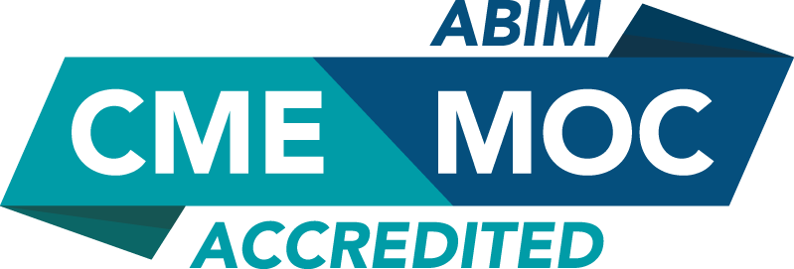

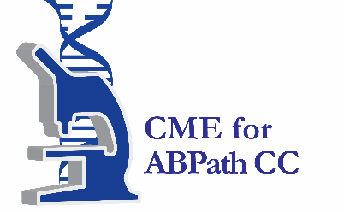

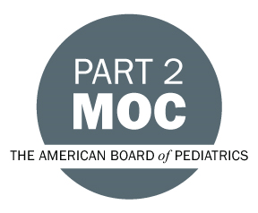

Faculty & Planner Disclosures
University of California, Irvine School of Medicine Continuing Medical Education adheres to the ACCME’s Standards for Integrity and Independence in Accredited Continuing Education. Any individuals in a position to control the content of a CE activity, including faculty, planners, reviewers, or others are required to disclose all relevant financial relationships with ineligible entities (commercial interests). All relevant conflicts of interest have been mitigated prior to the commencement of the activity.

Name of individual | Individual's role in activity | Nature of Relationship(s) / Name of Ineligible Company(s)
Christopher Browning, PhD | Faculty | Nothing to disclose - 12/21/2025
David Puder, MD | Course Director, Faculty | Nothing to disclose - 12/21/2025
Jeremiah Stokes, LPCC | Faculty | Nothing to disclose - 05/14/2025

Agenda
[INSERT AGENDA HERE MANUALLY]

Acknowledgement of Commercial Support
No commercial support has been received for this activity.

