10th Annual UCI Neuromuscular Pathology Colloquium

May 28, 2026

Purpose
This colloquium is designed to encourage an atmosphere of collaboration and interaction between the various neuromuscular specialists in the US, Canada and internationally. It is a forum to discuss advancements in neuromuscular medicine as it relates to cases in neuromuscular pathology and review interesting and challenging cases. Such activities are aimed to improve patient care by promoting closer research collaboration and the development of new research projects between the various groups and institutions.

Target Audience
Specialties – Neurology, Pathology & Laboratory Medicine, Pediatrics, Genetic And Genomic Medicine, Neurology
Professions – Physician, Non-Physician, Allied Health Professional, Audiologist, Medical Assistant, Medical Student, Nurse, Nurse Practitioner, Pharmacist, Physical Therapist, Physician Assistant, Resident Physician, Speech-Language Pathologist

Activity Objectives
1 Identify different clinical presentations and patterns of involvement in neuromuscular
diseases.

2 Understand genetic basis of inherited myopathies and advancements in gene therapies.

3 Identify features on muscle pathology that help distinguish distinct subtypes of inflammatory muscle diseases.

Accreditation Statement
The University of California, Irvine School of Medicine is accredited by the Accreditation Council for Continuing Medical Education to provide continuing medical education for physicians.

Designation Statement
The University of California, Irvine School of Medicine designates this Live Activity for a maximum of 6.00 AMA PRA Category 1 Credit(s)™. Physicians should claim only the credit commensurate with the extent of their participation in the activity.

California Assembly Bill 1195 and 241
This activity is in compliance with California Assembly Bill 1195 and 241, which require CME activities with patient care components to include curriculum in the subjects of cultural and linguistic competency & implicit bias. It is the intent of AB 1195 and AB 241 to encourage physicians and surgeons, CME providers in the State of California, and the Accreditation Council for Continuing Medical Education to meet the cultural and linguistic concerns of a diverse patient population and reduce health disparities through appropriate professional development. Please see the CME website, https://www.meded.uci.edu/CME/ for AB 1195 and AB 241 resources.





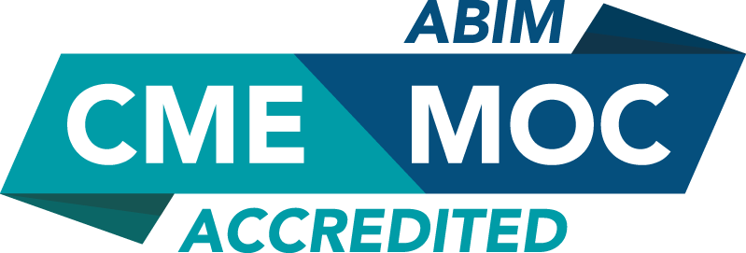

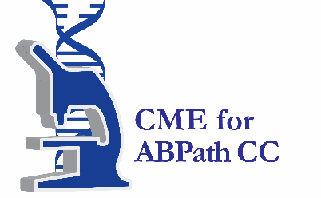

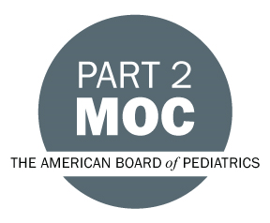

Faculty & Planner Disclosures
University of California, Irvine School of Medicine Continuing Medical Education adheres to the ACCME’s Standards for Integrity and Independence in Accredited Continuing Education. Any individuals in a position to control the content of a CE activity, including faculty, planners, reviewers, or others are required to disclose all relevant financial relationships with ineligible entities (commercial interests). All relevant conflicts of interest have been mitigated prior to the commencement of the activity.

Name of individual | Individual's role in activity | Nature of Relationship(s) / Name of Ineligible Company(s)
Suur Biliciler, MD | Course Director | Speakers Bureau-UCB|Honoraria-Amgen, Inc. (Relationship has ended) - 07/23/2025
Namita Goyal, MD | Course Director | Grant or research support-Abcuro|Grant or research support-Annexon|Grant or research support-Calico|Grant or research support-Clene|Grant or research support-Fulcrum (Relationship has ended)|Grant or research support-Janssen|Grant or research support-Medicinova|Grant or research support-MT Pharma (Relationship has ended)|Grant or research support-PepGen|Grant or research support-Prilenia|Grant or research support-PTC therapeutics (Relationship has ended)|Grant or research support-Roche|Grant or research support-Sanofi|Grant or research support-Transposon (Relationship has ended)|Speakers Bureau-Argenx|Speakers Bureau-CSL Behring - 07/15/2025
Ali A Habib, MD | Course Director | Grant or research support-argenx|Grant or research support-Alexion Pharmaceuticals|Grant or research support-UCB|Grant or research support-CabalettaBio|Grant or research support-Genentech (Any division)|Grant or research support-Immunovant|Grant or research support-Regeneron Pharmaceuticals, Inc.|Grant or research support-VielaBio-Horizon|Speakers Bureau-Alexion Pharmaceuticals|Speakers Bureau-UCB|Speakers Bureau-argenx|Membership on Advisory Committees or Review Panels, Board Membership, etc.-argenx|Membership on Advisory Committees or Review Panels, Board Membership, etc.-UCB|Membership on Advisory Committees or Review Panels, Board Membership, etc.-Roche (Any division) (Relationship has ended)|Paid consultant-NMDPharma|Grant or research support-Arcellx|Grant or research support-Novartis Corporation Pharmaceuticals|Grant or research support-Merck (Any division)|Grant or research support-NKarta|Consulting Fee-Grifols|Consulting Fee-Janssen (Any division)|Speakers Bureau-Janssen (Any division)|Consulting Fee-Kyverna|Grant or research support-Cour Therapeutics - 07/16/2025
Tahseen Mozaffar, MD, Professor | Course Director | Consulting Fee-Alexion Pharmaceuticals|Consulting Fee-Amicus|Consulting Fee-Sanofi|Consulting Fee-Fate Therapeutics|Consulting Fee-Maze Therapeutics|Grant or research support-Spark Therapeutics (Relationship has ended)|Consulting Fee-Cabaletta (Relationship has ended)|Grant or research support-AnnJi (Relationship has ended)|Grant or research support-Ask Bio|Consulting Fee-Horizon Therapeutics|Grant or research support-Cabaletta|Consulting Fee-Janssen (Any division) (Relationship has ended)|Consulting Fee-Argenx|Grant or research support-Argenx|Consulting Fee-Merck (Any division)|Honoraria-Muscular Dystrophy Association|Consulting Fee-Regeneron Pharmaceuticals, Inc.|Consulting Fee-UCB|Grant or research support-Astellas (Any division) - 07/15/2025
Mari Perez-Rosendahl, MD | Course Director | Nothing to disclose - 07/16/2025
Rachel Shulemson | Other Planning Committee Member | Nothing to disclose - 07/15/2025

Agenda
[INSERT AGENDA HERE MANUALLY]

Acknowledgement of Commercial Support
No commercial support has been received for this activity.

