2026 28 Hours of Otolaryngology Updates

February 20, 2026

Error! Unknown op code for conditional.

Target Audience
Specialties – Dermatology, Otolaryngology - Head & Neck Surgery, Plastic Surgery, Surgery, Surgical Oncology
Professions – Physician, Allied Health Professional, Audiologist, Medical Assistant, Medical Student, Nurse, Nurse Practitioner, Physician Assistant, Resident Physician, Speech-Language Pathologist

Activity Objectives
1 Define gender biases in patient management.
2 Manage complex sinonasal disorders and expand and develop surgical techniques for performing paranasal sinus surgery.

3 Expand the use of various hearing devices and surgical techniques with respect to treating diseases of the middle ear and cranial base.

4 Access, identify and perform the latest techniques in the management of laryngeal diseases and disorders of speech.

5 Expand surgical skills; specifically, to evaluate when open and closed rhinoplasty can be used.

Accreditation Statement
The University of California, Irvine School of Medicine is accredited by the Accreditation Council for Continuing Medical Education to provide continuing medical education for physicians.

Designation Statement
The University of California, Irvine School of Medicine designates this Live Activity for a maximum of 20.00 AMA PRA Category 1 Credit(s)™. Physicians should claim only the credit commensurate with the extent of their participation in the activity.

California Assembly Bill 1195 and 241
This activity is in compliance with California Assembly Bill 1195 and 241, which require CME activities with patient care components to include curriculum in the subjects of cultural and linguistic competency & implicit bias. It is the intent of AB 1195 and AB 241 to encourage physicians and surgeons, CME providers in the State of California, and the Accreditation Council for Continuing Medical Education to meet the cultural and linguistic concerns of a diverse patient population and reduce health disparities through appropriate professional development. Please see the CME website, https://www.meded.uci.edu/CME/ for AB 1195 and AB 241 resources.





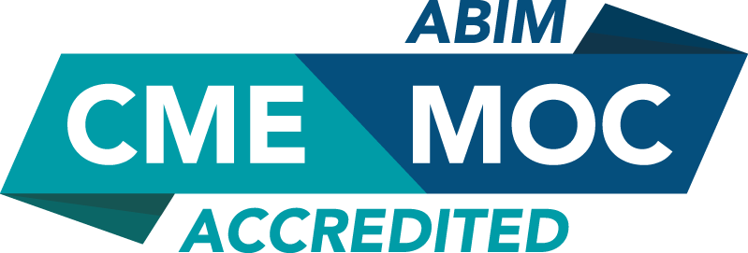

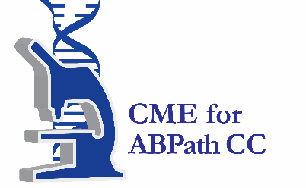

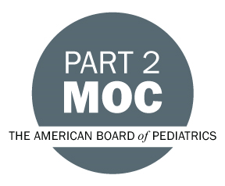

Faculty & Planner Disclosures
University of California, Irvine School of Medicine Continuing Medical Education adheres to the ACCME’s Standards for Integrity and Independence in Accredited Continuing Education. Any individuals in a position to control the content of a CE activity, including faculty, planners, reviewers, or others are required to disclose all relevant financial relationships with ineligible entities (commercial interests). All relevant conflicts of interest have been mitigated prior to the commencement of the activity.

Name of individual | Individual's role in activity | Nature of Relationship(s) / Name of Ineligible Company(s)
Eric H Abello, MD | Faculty | Nothing to disclose - 01/29/2026
Gurpreet S Ahuja, MD, Clinical Professor of Otolaryngology | Faculty | Nothing to disclose - 02/09/2026
Erik Antonsen, MD, PhD | Faculty | Nothing to disclose - 02/17/2026
William B Armstrong, MD | Faculty | Nothing to disclose - 02/03/2026
Gabriel Arom, MD | Faculty | Nothing to disclose - 01/14/2026
Phnam Bagley, Other | Faculty | Nothing to disclose - 02/19/2026
David Bailey, DPT, Fellow of Applied Functional Science | Faculty | Nothing to disclose - 01/29/2026
Pete Batra, MD, FACS, FARS | Faculty | Nothing to disclose - 01/24/2026
Christian Betz, MD, PhD | Faculty | Nothing to disclose - 02/04/2026
Naveen D Bhandarkar, MD | Faculty | Honoraria-Optinose (Relationship has ended)|Consulting Fee-Stryker (Any division) (Relationship has ended) - 01/27/2026
Jay Bhatt, MD | Faculty | Nothing to disclose - 01/30/2026
Elizabeth A Blair, MD, FACS | Faculty | Nothing to disclose - 01/22/2026
Arne MA Böttcher, MD, PhD | Faculty | Paid consultant-Inspire Medical Systems|Paid consultant-Nyxoah - 02/02/2026
Hansen Bow, MD, PhD | Faculty | Nothing to disclose - 02/06/2026
Carol R Bradford, MD | Faculty | Nothing to disclose - 02/04/2026
Tabita Breitsprecher, MD | Faculty | Nothing to disclose - 01/24/2026
Lisa Budelmann, MD | Faculty | Nothing to disclose - 02/20/2026
Benjamin Caughlin, Other, MD | Faculty | Nothing to disclose - 02/12/2026
Zenia Chow, MBBS | Faculty | Nothing to disclose - 01/25/2026
roxana cobo, MD | Faculty | Nothing to disclose - 05/17/2025
Richard Davis, MD, Voluntary Professor Univ of Miami School of Medicine | Faculty | Nothing to disclose - 01/30/2026
Hamid Djalilian, MD | Faculty | Advisor-Finally Quiet|Ownership-Elinava Technologies|Ownership-NeuroMed Care - 02/08/2026
Hossam MTM Foda, MD, Professor | Faculty | Nothing to disclose - 01/25/2026
David Gaertner, DO | Faculty | Nothing to disclose - 01/27/2026
Yarah Haidar, MD | Faculty | Advisor-Intuitive Surgical - 02/06/2026
Markus M. Hess, MD, PhD, Laryngologist | Faculty | Nothing to disclose - 02/11/2026
Anna S Hoffmann, MD | Faculty | Honoraria-Sanofi S.A.|Honoraria-GSK|Honoraria-AstraZeneca (Any division)|Honoraria-Medtronic (Any division) - 02/13/2026
Inna Husain, MD | Faculty | Consulting Fee-Smith & Nephew (Any division)|Other: VP of Education-Reflux Raft - 01/30/2026
Yong-Ju Jang, MD, PhD | Faculty | Nothing to disclose - 02/19/2026
Sung Huhn Kim, MD, PhD | Faculty | Nothing to disclose - 02/18/2026
Edward C Kuan, MD, MBA | Faculty | Consulting Fee-Stryker (Any division)|Royalties or Patent Beneficiary-Springer Books|Consulting Fee-3-D Matrix - 08/07/2025
Ming-Ying Lan, MD, PhD | Faculty | Nothing to disclose - 02/10/2026
Yoon Se Lee, MD, PhD | Faculty | Nothing to disclose - 02/19/2026
Dana R Levin, MD, MD MPH | Faculty | Nothing to disclose - 02/16/2026
Richard H Lewis, MBBS, FRACS | Faculty | Independent Contractor (included contracted research)-Restera|Stocks or stock options, excluding diversified mutual funds-Restera|Independent Contractor (included contracted research)-X11 Medical|Independent Contractor (included contracted research)-Nyxoah (Relationship has ended) - 01/21/2026
Harrison Lin, MD | Co-Director, Faculty | Nothing to disclose - 09/08/2025
Aline Mathieu, MD | Faculty | Nothing to disclose - 02/20/2026
Umang Mehta, MD | Faculty | Nothing to disclose - 02/08/2026
catherine meller, MBBS, FRACS(OHNS), MBA, MCL | Faculty | Nothing to disclose - 02/01/2026
Friederike Elisabeth Ugi Meyer, MD | Faculty | Nothing to disclose - 01/19/2026
Ethan G Muhonen, MD | Faculty | Nothing to disclose - 01/05/2026
Sepehr Oliaei, MD | Faculty | Nothing to disclose - 02/06/2026
Hong Ju Park, MD, PhD | Faculty | Nothing to disclose - 01/22/2026
Young Min Park, MD, PhD | Faculty | Nothing to disclose - 02/03/2026
Tuan V Pham, MBBS, FRACS | Faculty | Nothing to disclose - 01/21/2026
Nguyen Pham, MD | Faculty | Nothing to disclose - 02/19/2026
Mark Praetorius, MD | Faculty | Nothing to disclose - 02/06/2026
Alkis J Psaltis, MD, PhD, Professor Otolaryngology Head and Neck Surgery | Faculty | Consulting Fee-Medtronic (Any division)|Speakers Bureau-Karl Storz Endoscopy|Consulting Fee-Diceros|Consulting Fee-AstraZeneca (Any division)|Speakers Bureau-GSK|Speakers Bureau-Sanofi S.A. (Relationship has ended)|Stocks or stock options, excluding diversified mutual funds-Chitogel|Speakers Bureau-Stryker (Any division) - 01/19/2026
Abhita Reddy, MD, MBA | Faculty | Nothing to disclose - 02/04/2026
Dan Robinson, MBBS | Faculty | Nothing to disclose - 01/31/2026
Enrico Robotti, MD | Faculty | Nothing to disclose - 02/08/2026
Jennifer Rochlis, PhD | Faculty | Nothing to disclose - 02/03/2026
Stephen J Rodrigues, MBBS, FRACS (OHNS) | Faculty | Paid consultant-Cochlear - 01/27/2026
Paul Roh, DPT | Faculty | Nothing to disclose - 01/28/2026
Rod Rohrich, MD | Faculty | Royalties or Patent Beneficiary-Micrins Surgical|Grant or research support-Musculoskeletal Transplant Foundation|Consulting Fee-Musculoskeletal Transplant Foundation - 01/26/2026
Rahul K Shah, MD | Faculty | Nothing to disclose - 01/27/2026
Miriam R Smetak, MD | Faculty | Nothing to disclose - 01/22/2026
Kaleigh A Stabenau, MD | Faculty | Nothing to disclose - 02/12/2026
Rupert Stadlhofer, MD | Faculty | Nothing to disclose - 02/17/2026
Chad K Sudoko, MD | Faculty | Nothing to disclose - 01/31/2026
Myung-Whan Suh, MD, PhD | Faculty | Nothing to disclose - 01/21/2026
Mark Swanson, MD | Faculty | Nothing to disclose - 01/22/2026
Pongsakorn Tantilipikorn, MD, PhD | Faculty | Nothing to disclose - 01/20/2026
Tjoson Tjoa, MD | Faculty | Nothing to disclose - 02/19/2026
Cristian Trache, MD | Faculty | Nothing to disclose - 01/25/2026
Douglas Trask, MD | Faculty | Speakers Bureau-Inspire|Stocks or stock options, excluding diversified mutual funds-Stimaire|Consulting Fee-Nyxoah|Membership on Advisory Committees or Review Panels, Board Membership, etc.-Restora Medical - 02/03/2026
Prem Tripathi, MD | Faculty | Nothing to disclose - 01/26/2026
Lauren Umstattd, MD | Faculty | Nothing to disclose - 01/30/2026
Sunil Verma, md | Faculty | Nothing to disclose - 02/08/2026
Shyan Vijayasekaran, MD, PhD | Faculty | Nothing to disclose - 01/25/2026
Lukas Wittig, MD | Faculty | Nothing to disclose - 02/08/2026
Brian Wong, MD | Course Director, Faculty | Nothing to disclose - 08/07/2025
Henrike Zech, MD | Faculty | Speakers Bureau-Merck (Any division) (Relationship has ended)|Advisor-Regeneron Pharmaceuticals, Inc.|Speakers Bureau-BeOne|Speakers Bureau-LeoPharma - 02/08/2026

Agenda
[INSERT AGENDA HERE MANUALLY]

Acknowledgement of Commercial Support
No commercial support has been received for this activity.

