2024 Kidney/Pancreas Transplant & Nephrology Symposium

October 4, 2024

Purpose
The 2024 UCI Kidney/Pancreas Transplant & Nephrology Symposium will provide a detailed overview of the kidney and kidney/pancreas transplant patient care continuum. The course will focus on advancing collaboration between community physicians, nurses, social workers and dietitians who work together to promote health, wellness and care coordination for the transplant patient population.

Target Audience
Professions – Physician, Nurse, Nurse Practitioner, Other, Pharmacist, Physician Assistant, Registered Dietitian, Resident Physician, Social Worker

Activity Objectives
1 Explain the continuum of transplant patient care and management within the UCI Transplant Program and how to effectively manage patient care collaboratively with the transplant program after patient repatriation back into the community setting
1 Describe the importance of incorporating the multi-disciplinary approach into the care of the transplant patient population
2 Identify the challenges that come with caring for the pre-transplant, waitlist, post-transplant, and living donor patient populations

Accreditation Statement
The University of California, Irvine School of Medicine is accredited by the Accreditation Council for Continuing Medical Education to provide continuing medical education for physicians.

Designation Statement
The University of California, Irvine School of Medicine designates this Live Activity for a maximum of 6.50 AMA PRA Category 1 Credit(s)™. Physicians should claim only the credit commensurate with the extent of their participation in the activity.

California Assembly Bill 1195 and 241
This activity is in compliance with California Assembly Bill 1195 and 241, which require CME activities with patient care components to include curriculum in the subjects of cultural and linguistic competency & implicit bias. It is the intent of AB 1195 and AB 241 to encourage physicians and surgeons, CME providers in the State of California, and the Accreditation Council for Continuing Medical Education to meet the cultural and linguistic concerns of a diverse patient population and reduce health disparities through appropriate professional development. Please see the CME website, https://www.meded.uci.edu/CME/ for AB 1195 and AB 241 resources.



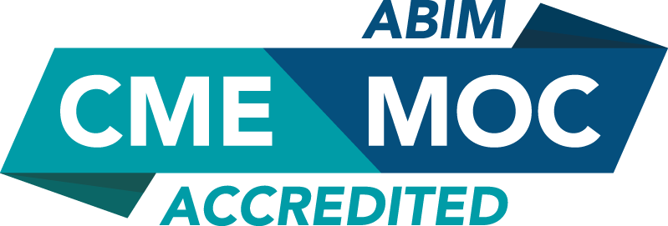

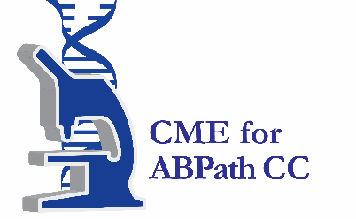

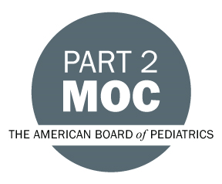

Faculty & Planner Disclosures
University of California, Irvine School of Medicine Continuing Medical Education adheres to the ACCME’s Standards for Integrity and Independence in Accredited Continuing Education. Any individuals in a position to control the content of a CE activity, including faculty, planners, reviewers, or others are required to disclose all relevant financial relationships with ineligible entities (commercial interests). All relevant conflicts of interest have been mitigated prior to the commencement of the activity.

Name of individual | Individual's role in activity | Nature of Relationship(s) / Name of Ineligible Company(s)
Hirohito Ichii, MD, PhD | Faculty | Nothing to disclose - 09/23/2024
Joseph C. Carmichael, MD | Planning Commitee Member | Nothing to disclose - 09/09/2024
Robert Redfield, MD | Course Director, Faculty | Nothing to disclose - 10/28/2023
Heather Abrari, MSN | Activity Coordinator | Nothing to disclose - 01/04/2024
Uttam G Reddy, MD | Faculty, Other Planning Committee Member | Nothing to disclose - 05/07/2024
Anne-Marie Lutrick, MSN, RN | Other Planning Committee Member
Ekamol Tantisattamo, MD, MPH, FACP | Faculty | Nothing to disclose - 05/20/2024
Kristen Ko, NP | Faculty | Nothing to disclose - 09/23/2024
Fawaz S. Al Ammary, MD, PhD, FAST | Faculty | Nothing to disclose - 03/30/2024
Antoney J. Ferrey, MD | Faculty | Nothing to disclose - 07/15/2024
Robin Worker, LCSW, PsyD | Faculty | Nothing to disclose - 09/23/2024
Sheila Alcantara, BSN, RN, CCTC | Faculty | Nothing to disclose - 09/23/2024
Cody Maynard, MBA | Faculty | Nothing to disclose - 09/20/2024
Natalie Tia, MPH | Faculty | Nothing to disclose - 09/20/2024
Sandra Skirvin, Other | Faculty | Nothing to disclose - 10/01/2024

Agenda
[INSERT AGENDA HERE MANUALLY]

Acknowledgement of Commercial Support
No commercial support has been received for this activity.

