Southern California Hypertension Symposium

May 16, 2026

Purpose
In celebration of the 2026 World Hypertension Day on May 16, 2026, the Hypertension Symposium offers in-person and live-streamed meetings in the form of a lecture and panel discussion as well as an optional workshop This meeting intends to provide its participants, who are responsible for measuring and/or managing blood pressure for both hypotension and hypertension, and general audiences who are interested in improving care for hypertension, with basic medical knowledge of blood pressure measurements in several methods, including traditional office blood pressure, automatic office blood pressure, self-measured blood pressure, ambulatory blood pressure, and automatic remoted blood pressure monitoring. Principal and practical aspects of blood pressure control, both non-pharmacologic and pharmacologic management, and interventional methods such as renal artery angioplasty and renal denervation, will be discussed. For the participants who are interested in training in blood pressure measurement to apply to their real-life or clinical practice, a blood pressure measurement workshop will provide the opportunity to practice with our staff at the UCI Comprehensive Hypertension Center to enhance their skills to be ready to utilize for their clinical practice.

Target Audience
Specialties – Anesthesiology & Perioperative Care, Dermatology, Emergency Medicine, Family Medicine, Medicine, Neurological Surgery, Neurology, Obstetrics & Gynecology, Ophthalmology, Orthopaedic Surgery, Otolaryngology - Head & Neck Surgery, Pathology & Laboratory Medicine, Pediatrics, Physical Medicine & Rehabilitation, Plastic Surgery, Psychiatry & Human Behavior, Radiation Oncology, Radiological Sciences, Surgery, Urology, Other
Professions – Physician, Non-Physician, Allied Health Professional, Medical Student, Other, Physician Assistant, Resident Physician

Activity Objectives
1 Provide education related to blood pressure measurements and management for healthcare providers who measure blood pressure or manage abnormal blood pressure.
2 Train accurate blood pressure measurement for healthcare providers who measure blood pressure
3 Implement blood pressure measurement and hypertension management in consistent with patients from different backgrounds in terms of cultural and linguistic competency.

Accreditation Statement
The University of California, Irvine School of Medicine is accredited by the Accreditation Council for Continuing Medical Education to provide continuing medical education for physicians.

Designation Statement
The University of California, Irvine School of Medicine designates this Live Activity for a maximum of 5.75 AMA PRA Category 1 Credit(s)™. Physicians should claim only the credit commensurate with the extent of their participation in the activity.

California Assembly Bill 1195 and 241
This activity is in compliance with California Assembly Bill 1195 and 241, which require CME activities with patient care components to include curriculum in the subjects of cultural and linguistic competency & implicit bias. It is the intent of AB 1195 and AB 241 to encourage physicians and surgeons, CME providers in the State of California, and the Accreditation Council for Continuing Medical Education to meet the cultural and linguistic concerns of a diverse patient population and reduce health disparities through appropriate professional development. Please see the CME website, https://www.meded.uci.edu/CME/ for AB 1195 and AB 241 resources.



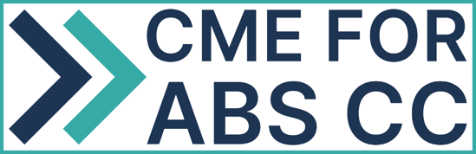

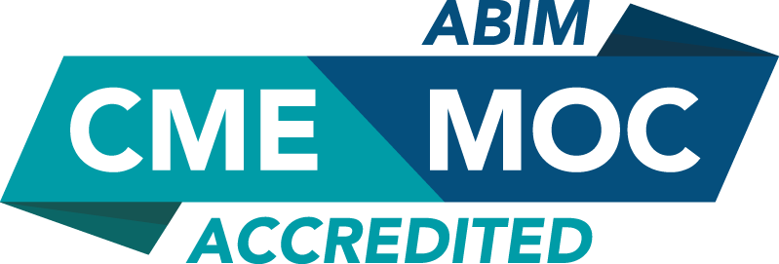

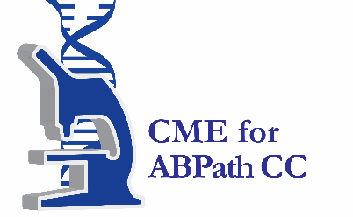

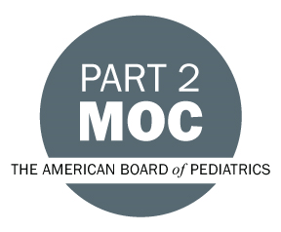

MOC Statement(s)

Successful completion of this CME activity, which includes participation in the evaluation component, enables the participant to earn up to 5.75 MOC point(s) in the American Board of Internal Medicine’s (ABIM) Maintenance of Certification (MOC) program. It is the CME activity provider’s responsibility to submit participant completion information to ACCME for the purpose of granting ABIM MOC credit.

Through the American Board of Medical Specialties (

Faculty & Planner Disclosures
University of California, Irvine School of Medicine Continuing Medical Education adheres to the ACCME’s Standards for Integrity and Independence in Accredited Continuing Education. Any individuals in a position to control the content of a CE activity, including faculty, planners, reviewers, or others are required to disclose all relevant financial relationships with ineligible entities (commercial interests). All relevant conflicts of interest have been mitigated prior to the commencement of the activity.

Name of individual | Individual's role in activity | Nature of Relationship(s) / Name of Ineligible Company(s)
Ailin Barseghian Elfarra, MD | Faculty | Speakers Bureau-Abbott (Any division) - 01/06/2026
Bernadette Boden-Albala, DrPH | Faculty | Nothing to disclose - 10/01/2025
Wenjun Fan, PhD | Faculty | Nothing to disclose - 03/02/2026
Wei Ling Lau, MD | Faculty | Nothing to disclose - 03/05/2026
Thu H Le, MD | Faculty | Advisor-Becton, Dickinson and Company (Relationship has ended) - 09/22/2025
Simin Liu, MD, PhD | Faculty | Nothing to disclose - 03/09/2026
Aya Ozaki, PharmD | Faculty | Nothing to disclose - 03/11/2026
Connie Rhee, MD | Faculty | Consulting Fee-AstraZeneca (Any division) (Relationship has ended)|Consulting Fee-Fresenius (Relationship has ended)|Consulting Fee-Dexcom (Relationship has ended)|Consulting Fee-Vifor (Relationship has ended) - 06/02/2025
Ekamol Tantisattamo, MD, MPH, FACP, FASN, FAHA | Course Director, Faculty | Nothing to disclose - 08/13/2025
Qin Yang, MD, PhD | Faculty | Nothing to disclose - 01/28/2026

Agenda
[INSERT AGENDA HERE MANUALLY]

Acknowledgement of Commercial Support
No commercial support has been received for this activity.

