Fifth Annual Spine by the Sea Symposium

July 24, 2026

Purpose
The current standards of practice in spine-related topics are aimed at fostering interactive dialogue and applying advanced educational knowledge in the management of various spinal conditions. These conditions include disc disease, radiculopathy/myelopathy, spondylolisthesis, spine trauma, sacroiliac joint pain, post-laminectomy syndrome, spinal tumors, and deformity/scoliosis. Through case reviews and studies, the goal is to guide the treatment of patients with spinal conditions, with a specific focus on advancing knowledge and patient care within California.

Target Audience
Specialties – Neurological Surgery, Orthopaedic Surgery
Professions – Physician, Non-Physician, Allied Health Professional, Medical Student, Nurse, Nurse Practitioner, Other, Physical Therapist, Physician Assistant, Resident Physician, Psychologist

Activity Objectives
1 Improve clinical knowledge of spinal pathology.
2 Identify various spinal disease and variations in treatment of spinal diseases.
3 Improve collaborative effort with other spine surgeons and related healthcare providers.
4 Engage in discussion about the various spinal diseases so that we can identify where the variations are and why different surgeons choose different treatments for the same spine pathology.

Accreditation Statement
The University of California, Irvine School of Medicine is accredited by the Accreditation Council for Continuing Medical Education to provide continuing medical education for physicians.

Designation Statement
The University of California, Irvine School of Medicine designates this Live Activity for a maximum of 7.25 AMA PRA Category 1 Credit(s)™. Physicians should claim only the credit commensurate with the extent of their participation in the activity.

California Assembly Bill 1195 and 241
This activity is in compliance with California Assembly Bill 1195 and 241, which require CME activities with patient care components to include curriculum in the subjects of cultural and linguistic competency & implicit bias. It is the intent of AB 1195 and AB 241 to encourage physicians and surgeons, CME providers in the State of California, and the Accreditation Council for Continuing Medical Education to meet the cultural and linguistic concerns of a diverse patient population and reduce health disparities through appropriate professional development. Please see the CME website, https://www.meded.uci.edu/CME/ for AB 1195 and AB 241 resources.





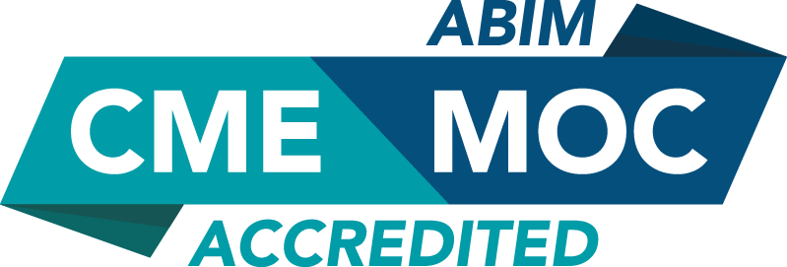



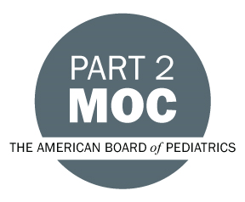



Faculty & Planner Disclosures
University of California, Irvine School of Medicine Continuing Medical Education adheres to the ACCME’s Standards for Integrity and Independence in Accredited Continuing Education. Any individuals in a position to control the content of a CE activity, including faculty, planners, reviewers, or others are required to disclose all relevant financial relationships with ineligible entities (commercial interests). All relevant conflicts of interest have been mitigated prior to the commencement of the activity.

Name of individual | Individual's role in activity | Nature of Relationship(s) / Name of Ineligible Company(s)
Navid Alem, MD | Faculty | Consulting Fee-Sprint Therapeutics - 05/25/2026
Nitin Bhatia, MD | Faculty | Royalties or Patent Beneficiary-Seaspine|Royalties or Patent Beneficiary-Spineart|Royalties or Patent Beneficiary-Aurora Spine|Consulting Fee-Lifespine|Paid consultant-difusion - 01/27/2026
Hansen Bow, MD, PhD | Faculty, Other Planning Committee Member | Nothing to disclose - 02/06/2026
Jonathan Fujii, PT, Physical therapist | Faculty | Nothing to disclose - 05/21/2026
Omid R. Hariri, DO, MSc, FACS | Faculty | Nothing to disclose - 07/07/2026
Sohaib Hashmi, MD | Faculty, Other Planning Committee Member | Paid consultant-Atec|Paid consultant-SI Bone |Paid consultant-LifeSpine|Paid consultant-SeaSpine - 07/08/2026
Frank Hsu, MD, PhD | Faculty | Ownership-AquaTex Medical |Grant or research support-Koh Young|Consulting Fee-Integra LifeSciences Corporation (Relationship has ended) - 04/14/2026
Namath Hussain, MD, MBA | Faculty | Nothing to disclose - 06/12/2026
Pawel Jankowski, MD | Faculty | Royalties or Patent Beneficiary-Orthofix-SeaSpine|Paid consultant-SI-Bone|Paid consultant-Induce Biologics|Paid consultant-Clariance Spinevision|Advisor-Clariance Spinevision|Paid consultant-AlphaTec|Grant or research support-AlphaTec|Royalties or Patent Beneficiary-AlphaTec|Paid consultant-DePuy (Any division) - 07/07/2026
Yu-Po Lee, MD | Course Director, Faculty | Nothing to disclose - 07/09/2026
David Majors, MD | Faculty, Planning Committee Member | Nothing to disclose - 06/16/2026
Rodney Mardirosian, MPH | Other Planning Committee Member | Nothing to disclose - 02/04/2026
Marin A McDonald , MD, PhD | Faculty | Nothing to disclose - 07/02/2026
Chris Mikhail, MD | Faculty | Consulting Fee-Globus Medical, Inc.|Consulting Fee-Medtronic (Any division)|Consulting Fee-DePuy (Any division) (Relationship has ended) - 04/13/2026
Emily Mills, MD | Faculty, Planning Committee Member | Nothing to disclose - 02/04/2026
Uzoma Mmeje, MHA | Planning Committee Member | Nothing to disclose - 01/22/2026
Peter O Newton, MD | Faculty | Royalties or Patent Beneficiary-DePuy (Any division) (Relationship has ended)|Consulting Fee-VB Spine|Royalties or Patent Beneficiary-VB Spine|Consulting Fee-Orthofix|Consulting Fee-Globus Medical, Inc.|Consulting Fee-Medtronic (Any division)|Ownership-SeeAllAI - 04/07/2026
Michael Oh, MD | Course Director, Faculty | Membership on Advisory Committees or Review Panels, Board Membership, etc.-2nd Skull|Consulting Fee-GS Medical|Membership on Advisory Committees or Review Panels, Board Membership, etc.-Intravent Medical - 04/21/2026
Burak Ozgur, MD | Faculty | Royalties or Patent Beneficiary-GS Medical|Royalties or Patent Beneficiary-SpineArt - 06/18/2026
Danielle Perret, MD | Faculty | Nothing to disclose - 03/20/2026
Jaida Robinson | Other Planning Committee Member | Nothing to disclose - 01/22/2026
Shalini Shah, MD, MBA | Faculty, Planning Committee Member | Consulting Fee-Allergan (Relationship has ended)|Consulting Fee-SPR Therapeutics|Consulting Fee-GateScience Inc (Relationship has ended)|Consulting Fee-Vertex Pharmaceuticals - 01/22/2026
Aaron Simon, MD | Faculty | Speakers Bureau-Icotec Medical Inc - 04/08/2026
Brian Su, MD | Faculty | Nothing to disclose - 06/12/2026
Lawrence C Wang, DO | Faculty | Stocks or stock options, excluding diversified mutual funds-Nanox - 07/21/2026
Jacqueline Weisbein, DO | Faculty | Consulting Fee-Abbott (Any division)|Speakers Bureau-Vertex Pharmaceuticals|Consulting Fee-SI Bone|Speakers Bureau-AbbVie (Any division) (Relationship has ended)|Consulting Fee-Vertos (Relationship has ended)|Grant or research support-Saluda (Relationship has ended)|Consulting Fee-Boston Scientific Corporation - 04/07/2026
Hao-Hua Wu, MD | Faculty, Other Planning Committee Member | Consulting Fee-BD|Consulting Fee-Globus Medical, Inc.|Membership on Advisory Committees or Review Panels, Board Membership, etc.-Maia|Consulting Fee-Orthofix|Consulting Fee-NeuralTrak - 01/28/2026
Carlen A Yuen, MD | Faculty | Nothing to disclose - 06/30/2026

Agenda
[INSERT AGENDA HERE MANUALLY]

Acknowledgement of Commercial Support
No commercial support has been received for this activity.

