Management of Challenging Behaviors in Autism Spectrum Disorders: ADHD

January 15, 2026 – November 30, 2026

Purpose
This CME activity was designed to increase the knowledge and competence of primary care providers in the care of patients with Autism Spectrum Disorder (ASD) and challenging or interfering behaviors. It is a 4-part learning series on the following topics, presented by Dr. Peter Chung, MD: 1. Management of Challenging Behaviors in Autism Spectrum Disorders: Evaluation and Screening 2. Autism Spectrum Disorder and Management: ADHD 3. Autism Spectrum Disorder and Management: Anxiety 4. Autism Spectrum Disorder and Management: Irritability

Target Audience
Specialties – Pediatrics, Behavioral And Developmental Pediatrics
Professions – Physician, Nurse, Nurse Practitioner, Physician Assistant

Activity Objectives
1 Describe the clinical approach to a patient with autism spectrum disorder (ASD) and attention-deficit/hyperactivity disorder (ADHD)
2 Apply strategies regarding the titration and dosing of medications for the treatment of co-occurring ADHD and ASD
3 List the main side effects of stimulants and non-stimulants, especially as seen in patients with ASD

Accreditation Statement
The University of California, Irvine School of Medicine is accredited by the Accreditation Council for Continuing Medical Education to provide continuing medical education for physicians.

Designation Statement
The University of California, Irvine School of Medicine designates this Enduring Material for a maximum of 1.00 AMA PRA Category 1 Credit(s)™. Physicians should claim only the credit commensurate with the extent of their participation in the activity.

California Assembly Bill 1195 and 241
This activity is in compliance with California Assembly Bill 1195 and 241, which require CME activities with patient care components to include curriculum in the subjects of cultural and linguistic competency & implicit bias. It is the intent of AB 1195 and AB 241 to encourage physicians and surgeons, CME providers in the State of California, and the Accreditation Council for Continuing Medical Education to meet the cultural and linguistic concerns of a diverse patient population and reduce health disparities through appropriate professional development. Please see the CME website, https://www.meded.uci.edu/CME/ for AB 1195 and AB 241 resources.





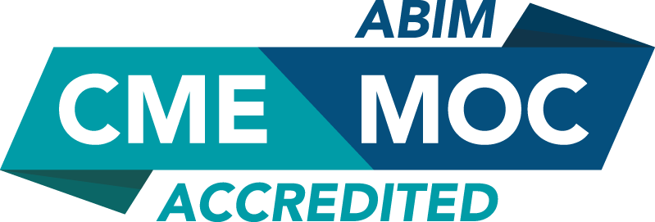

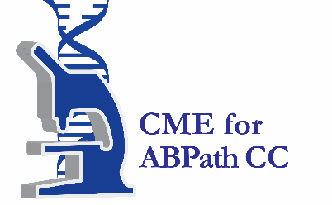

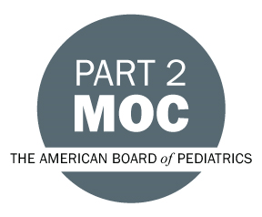

Faculty & Planner Disclosures
University of California, Irvine School of Medicine Continuing Medical Education adheres to the ACCME’s Standards for Integrity and Independence in Accredited Continuing Education. Any individuals in a position to control the content of a CE activity, including faculty, planners, reviewers, or others are required to disclose all relevant financial relationships with ineligible entities (commercial interests). All relevant conflicts of interest have been mitigated prior to the commencement of the activity.

Name of individual | Individual's role in activity | Nature of Relationship(s) / Name of Ineligible Company(s)
Peter Chung, MD | Course Director, Faculty | Advisor-Cell El Therapeutics - 10/23/2025
Elyse Schoenwald, CRNP, CPNP-PC, PMHS | Co-Director, Faculty | Nothing to disclose - 12/10/2025

Agenda
[INSERT AGENDA HERE MANUALLY]

Acknowledgement of Commercial Support
No commercial support has been received for this activity.

