HARMONICS 2026: The International Conference on Music, Medicine, & Science

October 28, 2026

Purpose
‘HARMONICS 2026: The International Conference on Music, Medicine, & Science’ is a multidisciplinary event exploring the intersection of music and health. Over two days, participants will engage with emerging research, technology, and experiential practice to advance understanding of how music can influence physiological and psychological outcomes. The program features keynote addresses, oral presentations across three thematic tracks (basic and translational research, innovation in music and medicine, and experiential clinical applications), poster sessions, and interactive demonstrations. This conference fosters collaboration among researchers, clinicians, educators, artists, and technologists to translate evidence into practice and shape the future landscape of music-based health interventions.

Target Audience
Specialties – Anesthesiology & Perioperative Care, Dermatology, Emergency Medicine, Family Medicine, Medicine, Neurological Surgery, Neurology, Obstetrics & Gynecology, Ophthalmology, Orthopaedic Surgery, Otolaryngology - Head & Neck Surgery, Pathology & Laboratory Medicine, Pediatrics, Physical Medicine & Rehabilitation, Plastic Surgery, Psychiatry & Human Behavior, Radiation Oncology, Radiological Sciences, Surgery, Urology, Other
Professions – Physician, Non-Physician, Allied Health Professional, Medical Student, Nurse, Nurse Practitioner, Other, Physical Therapist, Physician Assistant, Resident Physician, Clinical Social Worker, Psychologist

Activity Objectives
1 Describe current research evidence and emerging technologies demonstrating the effects of music on health outcomes such as pain, anxiety, stress, and neurological function.
2 Identify translational and experiential applications of music in medicine, including performance-based interventions and clinical case examples.
3 Discuss interdisciplinary approaches that integrate research, clinical practice, and creative arts to advance music-based health interventions.
4 Identify opportunities for collaboration among researchers, clinicians, artists, and technologists to support the implementation of music-centered approaches in healthcare and well-being, including culturally responsive approaches for diverse patient populations.

Accreditation Statement
The University of California, Irvine School of Medicine is accredited by the Accreditation Council for Continuing Medical Education to provide continuing medical education for physicians.

Designation Statement
The University of California, Irvine School of Medicine designates this Live Activity for a maximum of 9.00 AMA PRA Category 1 Credit(s)™. Physicians should claim only the credit commensurate with the extent of their participation in the activity.

California Assembly Bill 1195 and 241
This activity is in compliance with California Assembly Bill 1195 and 241, which require CME activities with patient care components to include curriculum in the subjects of cultural and linguistic competency & implicit bias. It is the intent of AB 1195 and AB 241 to encourage physicians and surgeons, CME providers in the State of California, and the Accreditation Council for Continuing Medical Education to meet the cultural and linguistic concerns of a diverse patient population and reduce health disparities through appropriate professional development. Please see the CME website, https://www.meded.uci.edu/CME/ for AB 1195 and AB 241 resources.





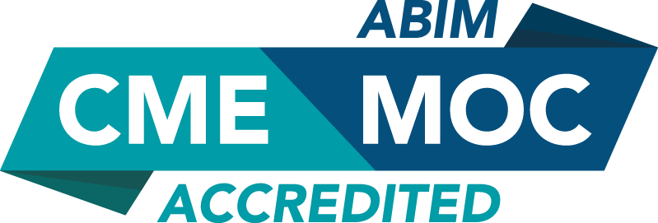

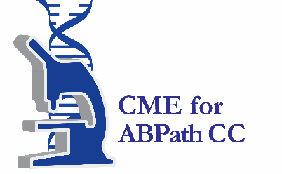

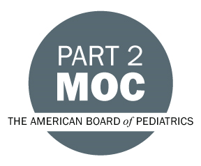



Faculty & Planner Disclosures
University of California, Irvine School of Medicine Continuing Medical Education adheres to the ACCME’s Standards for Integrity and Independence in Accredited Continuing Education. Any individuals in a position to control the content of a CE activity, including faculty, planners, reviewers, or others are required to disclose all relevant financial relationships with ineligible entities (commercial interests). All relevant conflicts of interest have been mitigated prior to the commencement of the activity.

Name of individual | Individual's role in activity | Nature of Relationship(s) / Name of Ineligible Company(s)
Shane Aspegren, BA | Faculty
Daniel Bowling, PhD | Faculty, Planning Committee Member | Ownership-Spiritune|Stocks or stock options, excluding diversified mutual funds-Spiritune|Stocks or stock options, excluding diversified mutual funds-Feed.fm|Advisor-Feed.fm - 02/06/2026
Jennifer L Buchanan, MBA, MTA - Certified Music Therapist (Canada) | Faculty
David Bychkov, PhD | Planning Committee Member | Nothing to disclose - 01/22/2026
Fabricio Cavero Farfan, PhD, Postdoctoral Scholar | Faculty
Kayla R Clark, PhD | Faculty
Rachel Dugas, MBA, Sound, Voice & Music Practitioner | Faculty | Nothing to disclose - 08/20/2026
Emi Ferguson, MM | Faculty | Nothing to disclose - 09/01/2026
Lisa Gibbs, Other, Department Chair | Co-Director, Faculty | Nothing to disclose - 08/25/2026
Deanna Hanson-Abromeit, PhD, MT-BC | Faculty
Brian Harris, MA, MT-BC, NMT/F | Faculty | Executive-MedRhythms - 08/21/2026
Kyurim Kang, PhD | Faculty | Nothing to disclose - 09/11/2026
Ruth Kasckow, MA, Musician, Educator | Faculty | Nothing to disclose - 08/24/2026
Albert A Le, LCSW | Planning Committee Member | Nothing to disclose - 01/30/2026
Sweta Mathur, PhD | Activity Coordinator, Faculty | Nothing to disclose - 01/22/2026
Julie Rousseau, PhD | Nurse Planner | Nothing to disclose - 09/04/2026
Soheil Saadat, PhD | Planning Committee Member | Nothing to disclose - 09/02/2026
Alexandra Stohs, MA | Faculty | Nothing to disclose - 09/11/2026
Sean Young, PhD | Course Director, Faculty | Advisor-Sonar Mental Health and ElvateU - 01/15/2026

Agenda
[INSERT AGENDA HERE MANUALLY]

Acknowledgement of Commercial Support
No commercial support has been received for this activity.

