Department of Surgery Annual Research Symposium

August 20, 2026

Purpose
Department of Surgery 6th Annual Research Symposium and Competition

Target Audience
Specialties – Surgery, Cardiothoracic Surgery, Colon & Rectal Surgery, Gastrointestinal Surgery, Hepatobiliary & Pancreas Surgery & Islet Cell Transplantation , Surgical Oncology, Transplantation, Trauma, Critical Care, Acute Care & Burn Surgery, Vascular & Endovascular Surgery
Professions – Physician, Non-Physician, Medical Student, Nurse, Nurse Practitioner, Other, Physician Assistant, Registered Dietitian, Resident Physician

Activity Objectives
1 Advance understanding of current and emerging research in diagnostic and therapeutic approaches for different surgery sub-specialties.
2 Update attendees on the most recent developments in general surgery by showcasing cutting edge surgery research, landmark studies, and evolving research outcomes that advance patient care and surgical practice.

Accreditation Statement
The University of California, Irvine School of Medicine is accredited by the Accreditation Council for Continuing Medical Education to provide continuing medical education for physicians.

Designation Statement
The University of California, Irvine School of Medicine designates this Live Activity for a maximum of 3.00 AMA PRA Category 1 Credit(s)™. Physicians should claim only the credit commensurate with the extent of their participation in the activity.

California Assembly Bill 1195 and 241
This activity is in compliance with California Assembly Bill 1195 and 241, which require CME activities with patient care components to include curriculum in the subjects of cultural and linguistic competency & implicit bias. It is the intent of AB 1195 and AB 241 to encourage physicians and surgeons, CME providers in the State of California, and the Accreditation Council for Continuing Medical Education to meet the cultural and linguistic concerns of a diverse patient population and reduce health disparities through appropriate professional development. Please see the CME website, https://www.meded.uci.edu/CME/ for AB 1195 and AB 241 resources.





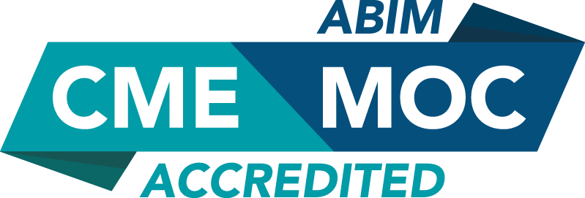



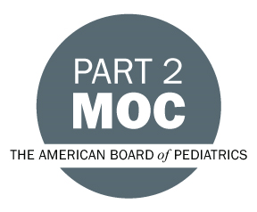



Faculty & Planner Disclosures
University of California, Irvine School of Medicine Continuing Medical Education adheres to the ACCME’s Standards for Integrity and Independence in Accredited Continuing Education. Any individuals in a position to control the content of a CE activity, including faculty, planners, reviewers, or others are required to disclose all relevant financial relationships with ineligible entities (commercial interests). All relevant conflicts of interest have been mitigated prior to the commencement of the activity.

Name of individual | Individual's role in activity | Nature of Relationship(s) / Name of Ineligible Company(s)
Zoe N Adams, BA | Faculty | Nothing to disclose - 07/10/2026
Reed Ayabe, MD | Faculty | Consulting Fee-Applied Medical - 06/27/2026
Daniela A Bota, MD, PhD | Faculty | Nothing to disclose - 12/01/2025
ELLIOT BOTVINICK, PhD | Faculty | Nothing to disclose - 07/14/2026
April Carlson, MD | Faculty | Nothing to disclose - 07/09/2026
Emma Caudill, B.S. Biochemistry and Molecular Biology | Faculty | Nothing to disclose - 07/14/2026
Anthony H Chau, MD, FACS | Faculty | Consulting Fee-Inari now Stryker|Grant or research support-Inari now Stryker|Grant or research support-Medtronic (Any division)|Consulting Fee-Medtronic (Any division)|Stocks or stock options, excluding diversified mutual funds-Abbott (Any division) (Relationship has ended)|Grant or research support-Gore Medical|Consulting Fee-Asahi Intecc - 07/16/2026
Alex N Dang, MD | Faculty | Nothing to disclose - 07/01/2026
Michael de Virgilio, MD | Faculty | Nothing to disclose - 07/08/2026
Oliver Eng, MD | Faculty | Paid consultant-Dilon Technologies, Inc. and xTant Medical|Paid consultant-Applied Medical Resources Corporation|Stocks or stock options, excluding diversified mutual funds-Iovance Biotherapeutics - 06/26/2026
Nicole Finney, MD | Faculty | Nothing to disclose - 06/28/2026
Laura F Goodman, MD, MPH | Faculty | Nothing to disclose - 06/25/2026
Areg Grigorian, MD | Faculty | Nothing to disclose - 06/23/2026
Kai He, MD | Faculty | Nothing to disclose - 06/26/2026
Mallory Jebbia, MD | Faculty | Nothing to disclose - 07/13/2026
Alyssa Joachim, MD | Faculty | Nothing to disclose - 06/26/2026
Lorraine Kelley-Quon, MD | Faculty | Nothing to disclose - 06/30/2026
Hari B Keshava, MD | Faculty | Consulting Fee-AstraZeneca (Any division)|Membership on Advisory Committees or Review Panels, Board Membership, etc.-DAVA Oncology|Membership on Advisory Committees or Review Panels, Board Membership, etc.-AstraZeneca (Any division)|Advisor-Merck (Any division) - 12/24/2025
Alexandra Leone, BA, Education Manager | Other Planning Committee Member | Nothing to disclose - 02/12/2026
Shray Malik, MD | Faculty | Nothing to disclose - 06/23/2026
Carla I Miret Durazo, MD | Faculty | Nothing to disclose - 07/01/2026
Jeffry Nahmias, MD | Co-Director, Faculty | Nothing to disclose - 06/22/2026
Ninh T Nguyen, MD | Faculty | Speakers Bureau-Olympus Corporation|Speakers Bureau-Merit Medical - 04/28/2026
Peter Nguyen, MD | Faculty | Nothing to disclose - 06/22/2026
Robert Redfield, MD | Faculty | Nothing to disclose - 03/30/2026
Emika G Saito | Faculty | Nothing to disclose - 07/01/2026
Maheswari Senthil, MD | Co-Director, Faculty | Consulting Fee-GE Healthcare|Consulting Fee-On Target - 03/25/2026
Brian R Smith, MD, FACS, FASMBS | Faculty | Nothing to disclose - 02/21/2026
Lourdes Swentek, MD | Faculty | Nothing to disclose - 06/22/2026
Jaya M Travis, BS | Faculty | Nothing to disclose - 06/29/2026
Marco Ventin, MD | Faculty | Nothing to disclose - 07/13/2026
Valery Vilchez, MD | Faculty | Consulting Fee-Applied Medical - 06/22/2026
Jingjing Yu, MD | Faculty | Nothing to disclose - 07/02/2026
Peter Yu, MD | Faculty | Nothing to disclose - 06/25/2026
Jeffrey Zhou, BS | Faculty | Nothing to disclose - 12/17/2025

Agenda
[INSERT AGENDA HERE MANUALLY]

Acknowledgement of Commercial Support
No commercial support has been received for this activity.

